AZ-103: Short Note

*By Wayan Wijesinghe*

This note was created for my personal use. Since, I too used multiple Free resources to study for this exam, thought of sharing this for anyone’s use.

I am sharing this in Microsoft Word format so that you can add your own study notes and make it richer. And then keep sharing. Please note that Microsoft is updating content very frequently. Hence, please use this as support material only.

Table of Contents

Sources: 1

MA 02 - Virtual machines 2

Creating a VM 9

Creating a VM in the Azure portal 9

Basic 9

Disks 10

Networking 10

Management 11

virtual machine scale set 11

Creating a scale set 12

Over provisioning 12

No of instances 13

When to use auto scaling 14

Virtual machine sizing 14

Availability 15

Availability set (99.95%) 16

Scalability set (this also is an availability domain) 16

Availability zone (99.99%) 16

Creation of a load balancer 18

Restart vs stop and start 18

Automation 19

Azure Storage 21

Storage Intro 22

Types or storage 22

Standard v Premium Storage accounts 23

Account kind 23

Accessing Storage 24

Blob Storage 26

Intro 26

Types of blobs 27

Azure file storage 28

Introduction 29

Benefits 29

Creating a file share 29

How to Access --> Mount 30

Secure transfer required (HTTPS traffic only.) 30

File share snapshot 30

Extra azure file sync 30

Storage Security 31

Introduction - Storage security 32

SAS 32

4 Virtual networking 35

Virtual Networks 36

Virtual Networks 37

Subnets 37

Creating vnet 38

IP Addressing and Endpoints 39

IP Addressing 40

Endpoints 42

Azure DNS 44

Azure DNS zone 45

DNS Record set 46

DNS Delegation 47

Private DNS Zone 47

NSG 48

NSG Rules 50

Demo: go to NSG 51

5. Inter-site connectivity 52

VNET Peering 52

Create a peering 53

Gateway Transit 55

Global Vnet peering 56

Service chaining 56

Vnet-to-Vnet Connections 57

Create vnet-vnet connection 59

Create virtual network gateway --> VPN networks takes a lot of time to create (45 mins) 60

Create local network gateway 62

Create the connection 63

Verify the connection 64

Express route 64

Review questions 66

6. Azure Monitoring 67

Azure Monitor 67

Azure alerts 71

Log Analytics 73

Query language 75

Network Watcher 76

7. Data Protection 80

Data replication (Replication for storage) 80

Replication options 81

Files and Folders Backup 83

How to initiate a backup 84

Virtual machine backup 86

Things to clarify before starting backups 88

How to take a VM backup? 89

Azure site recovery - Onsite 90

8. Network Traffic Management 92

Network Routing 92

Azure Load Balancer 95

Azure Traffic Manager 100

9. Active Directory 105

Active Directory Connect 109

Azure AD Join 113

10: Securing Identities 116

MFA 116

Identity Protection 119

Self-service password reset 121

11: Governance & Compliance 124

Subscriptions and accounts 124

RBAC 129

Users and Groups 132

12: Data Services 136

CDN 137

File Sync 140

Azure Import Export 142

Data Box 145

# Sources:

FREE: [Azure AZ-103 Exam Prep](https://www.youtube.com/watch?v=xzm6DS-W2SQ&list=PL2cpErdp4pbDBl9J7rts6VNwr3U-l-LXG) by Cloud and you, (YouTube)

FREE: [Microsoft Documentation](https://docs.microsoft.com/en-au/azure/)

PAID: [AZ-103 Azure Administrator Exam Certification 2020](https://www.udemy.com/course/70533-azure/) by Scott Duffy (Udemy)

PAID: [Microsoft AZ-103: Azure Administrator Exam Certification](https://www.udemy.com/course/az-100-skylines-academy/) by Nick Colyer, Skylines Academy (Udemy)

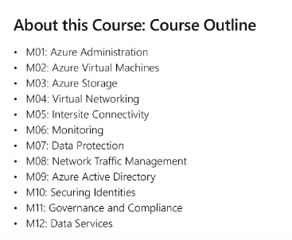

# MA 02 - Virtual machines

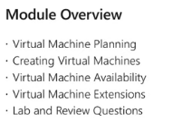

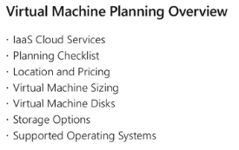

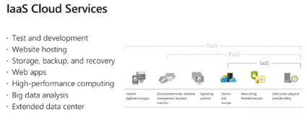

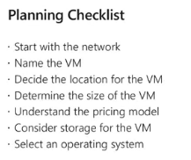

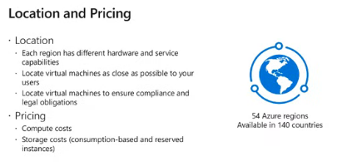

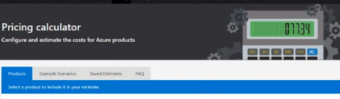

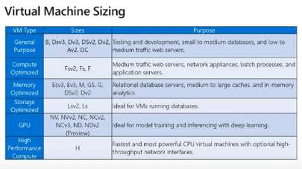

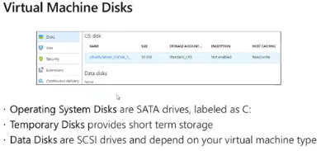

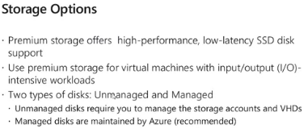

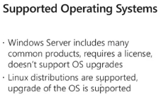

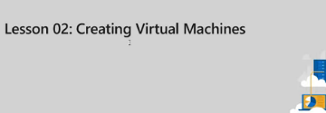

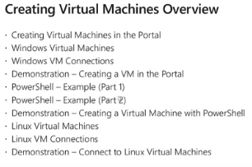

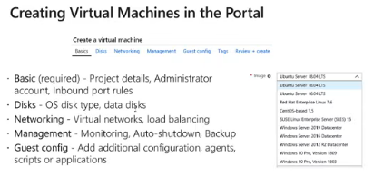

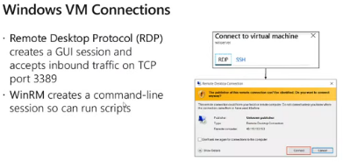

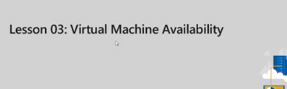

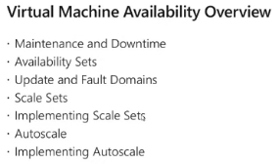

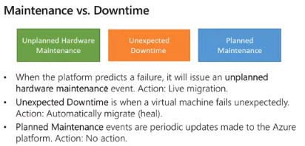

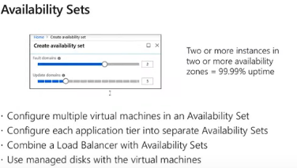

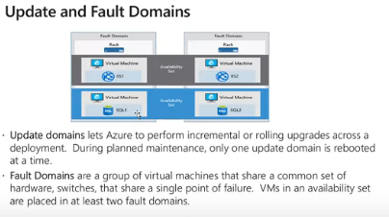

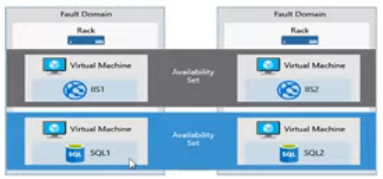

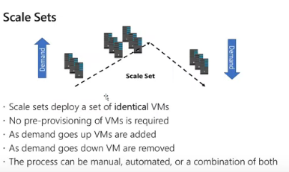

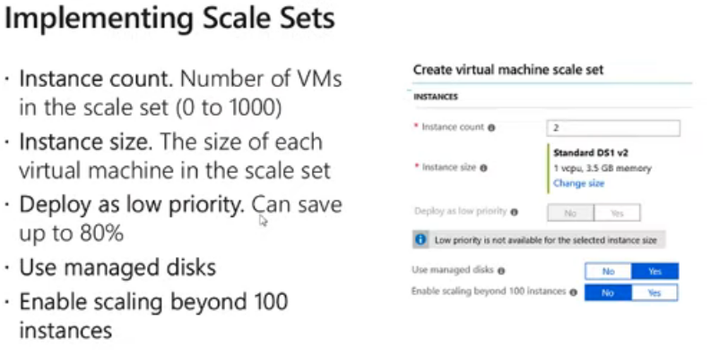

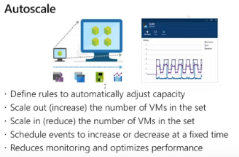

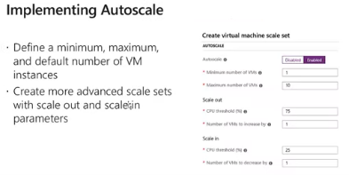

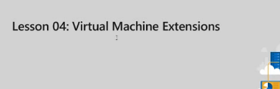

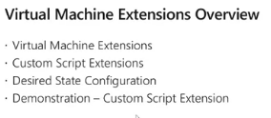

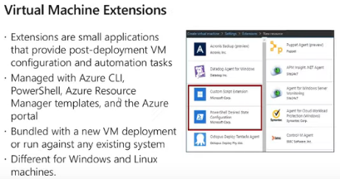

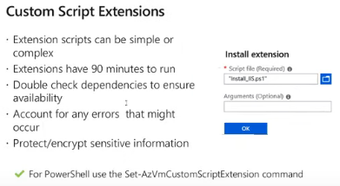

## Creating a VM

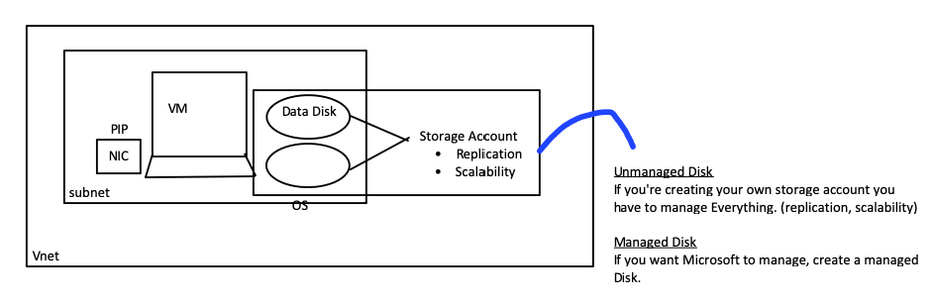

* Required resource in Azure to create a VM
  + - * Computer and memory
        + Choosing the images
        + Sizing the VM (refer VM size below)
      * Storage account

|  |  |
| --- | --- |
| Unmanaged Vs managed |  |

* + - * OS and data disks
      * Virtual network
      * NIC
      * IP Address

## Creating a VM in the Azure portal

### Basic

* + - Availability options
    - Size
      * Different performance parameters
      * # of and types of network interface cards (Accelerated networking)
      * # of data disks allowed
      * Type of storage and
      * 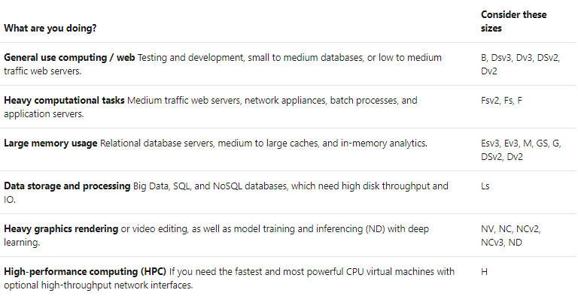
    - Inbound port rules
      * Ability to access from the internet. RDP 3389
      * NSG deny public access by default.
    - Save Money
      * If your organization already has windows volume license, save money from that

### Disks

* OS Disk type
  + MS Creates one operating system disk (C:) and a temporary disk for short-term storage. (D:)
  + The default size is 127 GB. This is more than enough for OS, so Microsoft set it as the default --> This can be increased to 2TB.

|  |  |
| --- | --- |
| **Premium SSD** | **Standard HDD** |
| electric signals | Magnetic |
| Higher performance  250 MBps or 7500 256KB IOPS per disk | Lower Performance  60Mbps or 500 8-KB IOPS per disk |
| Expensive | Cheaper |

* 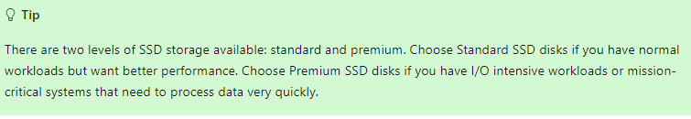
* Managed Disks

|  |  |
| --- | --- |
| **Managed** | **Unmanaged** |
| MS will take care of scalability and replication etc. Microsoft recommends | You are creating your own storage account and you must separately take care of scalability replication etc. |

* Data Disks
  + Max size 4TB
* Support Vhd only. vhdx is not supported.
* Supports generation 1 only
* To use an existing Vhd, upload it to a storage account and select that as a data disk

### Networking

* + Virtual network
  + Subnet
  + Public IP
  + Network Security group

|  |  |
| --- | --- |
| Basic | Advanced |
| Only ports and protocols | Can select source & destination IPs |

* + Accelerated networking
    - Available in the network interface card
    - Low latency and high throughput
    - Available in the selected VM size

### Management

* + Boot diagnostics --> if there is any problem with the booting process can analyze these)
  + OS Guest diagnostics --> OS Logs
  + Needs a storage account
    - Doesn’t allow managed disk. Must create a storage account.
  + Identity > Identity access mgt
  + Auto shutdown
    - If you forget to shut down the VM. Especially in testing & Dev. Don’t use in Production envt.
  + Backup > Take backups of the VM
  + Guest config
  + Extensions
    - Small applications by different providers that can be installed/controlled in VM without even going into the VM
  + Tags
  + For identification and categorization. E.g. Costs A key-value pair.
    - E.g. Dept - IT, Version - 1.2, Env - Production

## virtual machine scale set

* Collection of identically configured VM's

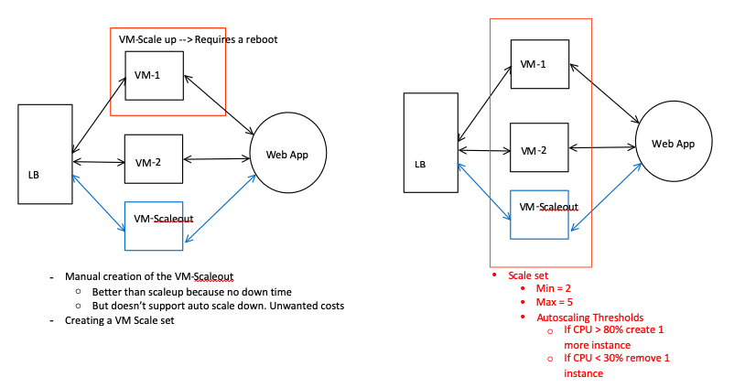

|  |  |
| --- | --- |
| **Manual group of Virtual machines** | **Scale set** |
| * + - * Can run both stateless and stateful apps | * + - * Can only be used for stateless applications         + Web applications, big data, big compute       * Cannot be used for stateful applications         + SQL Databases |
| * + - * Each Have NICs.       * Can use IPV6 | * + - * Instances doesn’t have a NIC attached to it. Only IP is the Load balancer/Application GW IP       * Therefore, cannot assign IPV6 Addresses to individual machine |
| * + - * Have full control | * + - * You don’t have control of what machine to be created or deleted. Highest instance-ID is always deleted. |
| * + - * Can capture an image of a VM as they have their own OS images. | * + - * Cannot capture images of OS. Same image is replicated in each VM. |
| * + - * No Auto Scaling | Auto Scaling |
| * + - * Manually create Availability Set or distribute and track VMs across Availability Zones | * + - * Automatic distribution of VM instances across Availability Zones or Availability Sets |

### Creating a scale set

* Operating disk image
  + In scale sets can use custom images. But this will limit the number of instances
* Instance count
* Instance size
* Low priority instances
  + Lower cost than normal instances
  + But MS can evict it at anytime
  + 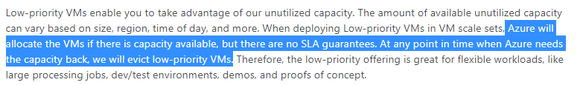
* Advanced setting - Enable scaling beyond 100 instances
  + In a single scale set max is 100 instances if the single placement group is True
  + If you need more, they have been **placed in a scale set single placement group should be false**
* Auto scale
  + Min number
  + Max number
  + Scale out - Threshold, number of vms to increase
  + Scale in -
    - CPU is not the only parameter that you can use to scale
* Networking
  + Load balancing option
    - Application gw
    - Load balancer
  + Configure Virtual Networking
    - Network
    - Subnet
    - Public IP
    - Accelerated NIC

### Over provisioning

* + In the example after creating 2 instances, it has created 4
  + Over provisioning is set to true by default when creating scale set
  + MS will deploy more instances that the necessary
  + Why - To ensure that there are not delays due to any provisioning errors. E.g. If no overprovisioning, if there is an error in provisioning, it must start again from the beginning. In overprovisioning, more than required is created and will be removed once the required number of VMs are provisioning correctly

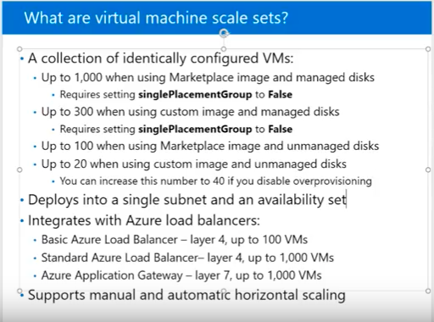

### No of instances

|  |  |  |
| --- | --- | --- |
|  | **Marketplace image** | **Custom image** |
| **Managed disk** | 1,000 | 300 |
| **Unmanaged Disk** | 100 | 20  40 if overprovisioning is disabled |

* + Every time there is more than 100, single placement group is disabled
  + Load balancing in Scale set
    - Basic LB - 100
    - Std LB - 1000
    - Azure application gateway - 1000

### When to use auto scaling

* + 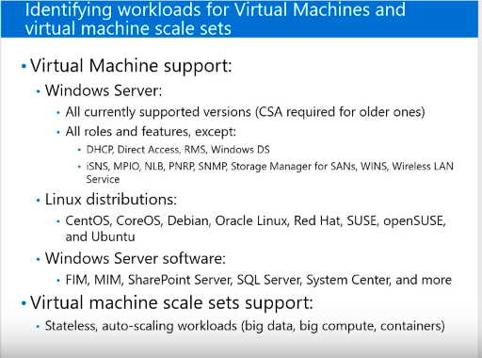
  + Stateless/ stateful workloads, Monolithic / distributed application architecture

## Virtual machine sizing

* + 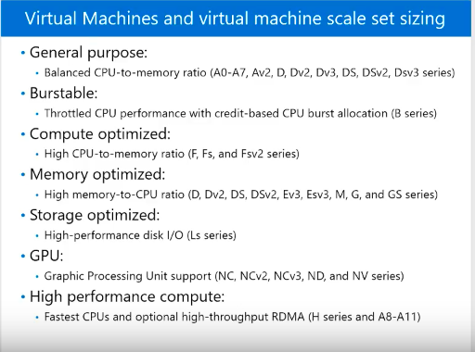

## Availability

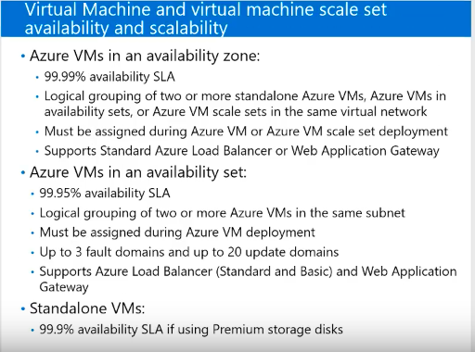

* 5 9's (99.999%) is the most sought-after availability
* Types of down time
  + Planned maintenance
    - periodic updates made by Microsoft to the underlying Azure platform to improve overall reliability, performance, and security
    - Updates are done on one update domain at a time
    - Some cases a reboot is necessary
  + Unplanned hardware maintenance
    - MS get to know that HW is going to fail
    - Proactively **Live migration** will happen
    - No rebooting of the machine. Only pausing
    - Short term reduction in performance
    - Memory, open files, and network connections are maintained,
  + Unexpected downtime
    - MS doesn’t know the HW fail in advanced
    - can include local network failures, local disk failures, or other rack level failures.
    - virtual machines experience downtime (reboot) and in some cases loss of the temporary drive.
    - Reboot will happen
    - NIC, Storage everything will go down
    - RAM and working files will be deleted

* To overcome this
  + [Configure multiple virtual machines in an availability set for redundancy](https://docs.microsoft.com/en-us/azure/virtual-machines/windows/manage-availability#configure-multiple-virtual-machines-in-an-availability-set-for-redundancy)
  + [Use managed disks for VMs in an availability set](https://docs.microsoft.com/en-us/azure/virtual-machines/windows/manage-availability#use-managed-disks-for-vms-in-an-availability-set)
  + [Use scheduled events to proactively response to VM impacting events](https://docs.microsoft.com/azure/virtual-machines/virtual-machines-scheduled-events)
  + [Configure each application tier into separate availability sets](https://docs.microsoft.com/en-us/azure/virtual-machines/windows/manage-availability#configure-each-application-tier-into-separate-availability-zones-or-availability-sets)
  + [Combine a Load Balancer with availability sets](https://docs.microsoft.com/en-us/azure/virtual-machines/windows/manage-availability#combine-a-load-balancer-with-availability-zones-or-sets)
  + [Use availability zones to protect from datacentre level failures](https://docs.microsoft.com/en-us/azure/virtual-machines/windows/manage-availability#use-availability-zones-to-protect-from-datacenter-level-failures)

### Availability set (99.95%)

* VM can be put in an Availability at creation only. Once it is created you can't put them in an availability set
* VMs are put in up to 3 fault domains (No impact from unexpected downtime and unplanned HW maintenance)
* VMs are put in up to 20 update domains (no impact from planned downtime)

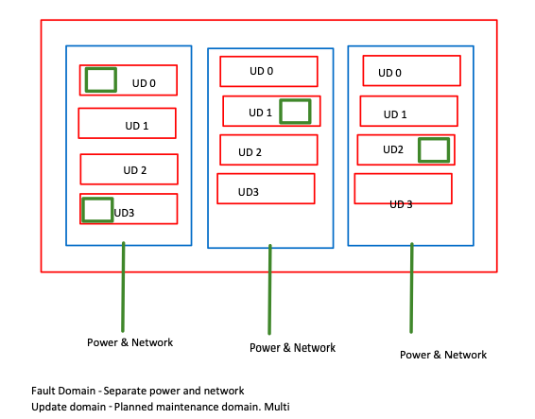

### Scalability set (this also is an availability domain)

* 5 fault domains and 5 update domains
* Scaling when
  + On demand
  + Scheduled
  + Automatic
    - Based on host metrics
    - Based on guest os metrics (require diagnostic extension)

### Availability zone (99.99%)

* Protects the application from data center level failure
* VM Put in multiple data centers in the same availability zone
* One region can have multiple AZ
* Available in only selected regions

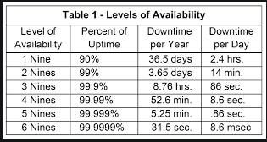

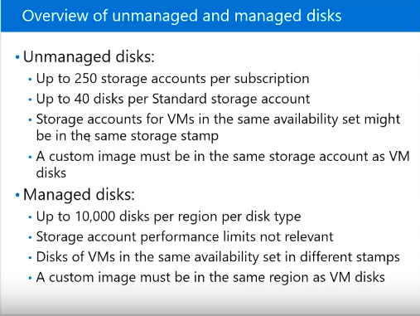

### Creation of a load balancer

* 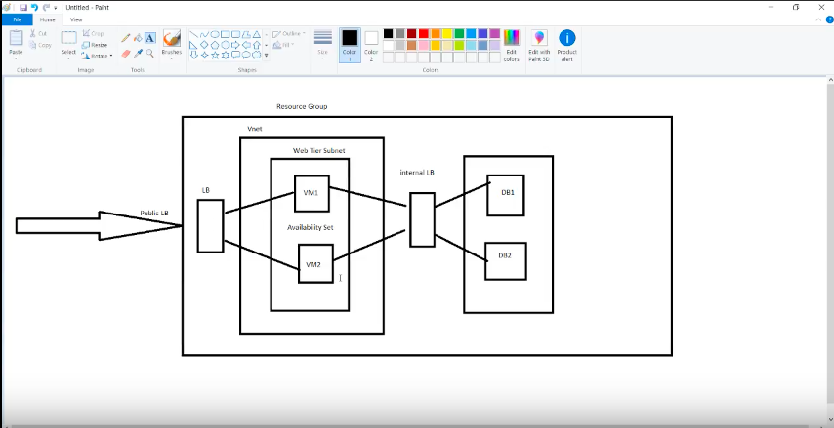
  1. Create the availability set
  2. Create the virtual machines and whilst doing that assign them to availability set (99.95% availability). Install the webservers. IIS (cannot be changed later. Must be at the creation of the VM)
  3. Create the load balancer (in scale set creation, within that load balancer is created)
  4. Configure the load balancer
     1. Backend pool - Adding the servers to the LB
     2. Health probe - required to monitoring the VMs in load balancing
        1. Interval-> interval between two checks
        2. Threshold -> after how many checks should the load balancer stop sending traffic
     3. Load balancing rules -
  5. Open the ports 80 in the VM's

### Restart vs stop and start

* + Restart - Dynamic data (IP, Temp data) won't change.
  + Stop and start (de-allocation) - RAM lost

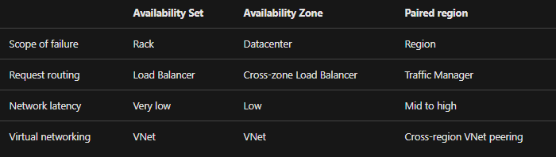

## Automation

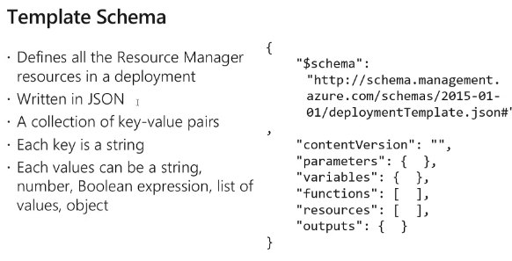

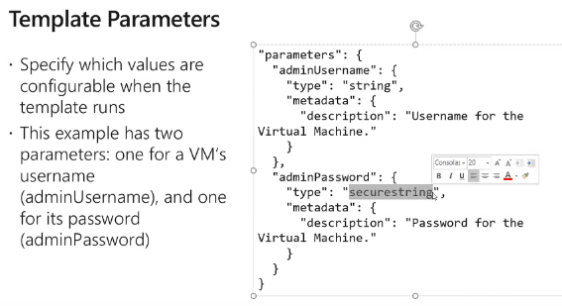

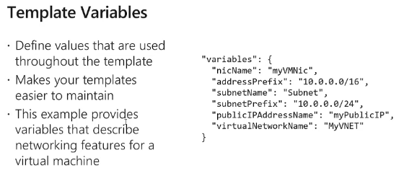

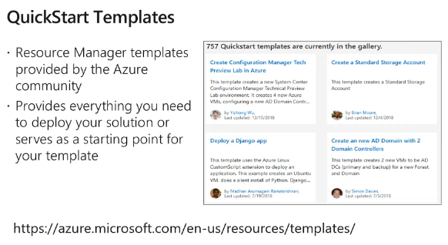

# Azure Storage

[Azure AZ-103 Exam Prep M3-L1 Azure Storage](https://www.youtube.com/watch?v=A6bDwt3zrJs)

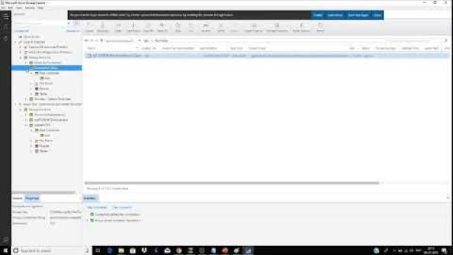

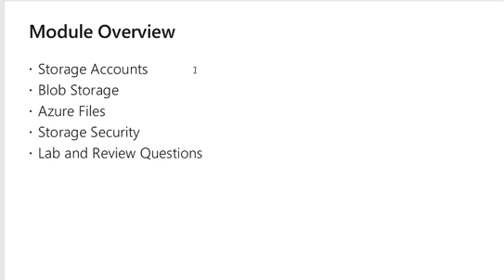

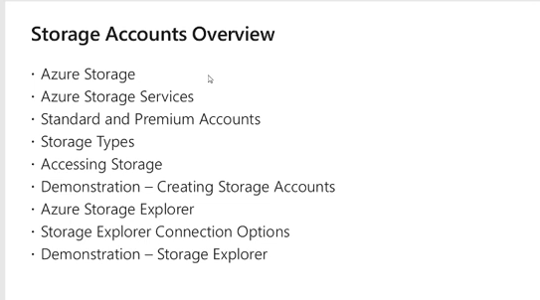

## Storage Intro

* + Azure Storage is a service
    - Service - Functionality offered in azure
    - Resource - Instance created using the service for our own use
  + Benefits
    - Durable,
    - Secure (encrypted an Access controlled)
    - Scalable
    - Managed (no hassle for us)
    - Accessible (Multiple apis and protocols)
  + Isolated - Storage accounts won’t interact with each other

* Types of Data stored
  1. VM - Disks (Page blobs) and file shares (Files)
  2. Unstructured data
     + Blobs - Any kind of binary data Audio video and files
     + Data lake store -
  3. Structured data - Any data arranged in a format
     + Tables, Cosmos DB, Azure SQL DB

## Types or storage

|  |  |  |  |
| --- | --- | --- | --- |
| **Blobs** | **Files** | **Tables** | **Ques** |
| Unstructured data and VM disks | VM Disks | Structured data | Reliable messaging store |
| Accessible via internet friendly protocols HTTP HTTPS | Accessible via non-internet friendly protocols SMB3.0  Too. (Internet friendly is also) |  |  |
| A URL | A Drive mapped to a drive in the system |  |  |

* 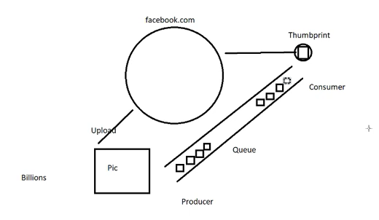

### Standard v Premium Storage accounts

|  |  |
| --- | --- |
| **Standard** | **Premium** |
| Magnetic Drives (HDD) | Solid state devices (SDD) |
| Lowest cost per GB |  |
| Higher performance  250 MBps or 7500 256KB IOPS per disk | Lower Performance  60Mbps or 500 8-KB iops per disk |
| Usual files folders videos | Performance hungry data   * + - * + VM disk         + SQL Databases |

* Cannot be changed once the storage account is created

### Account kind

|  |  |  |
| --- | --- | --- |
| **Gen V2** | **Gen V1** | **Blob storage** |
| Latest version  Lowest price  Supports all services  Microsoft recommends | only for backward compatibility. | Specialized for storing unstructured data |

* Upgrading can be done later

|  |  |
| --- | --- |
|  | Performance tier support |
| Genv2  Latest version. Lowest price. Recommended for most scenarios using Azure Storage | * + Standard - Support all. All redundancy available   + Premium - Blob storage only. (Page, file, Block). And only LRS available |
| Genv1  Legacy | * + Standard - support all. Geo zonal redundancy not available.   + Premium - Blob storage only. (Page, file, Block). And only LRS available |
| Block Blob | * + Standard - N/A   + Premium - Available. Only premium. premium performance characteristics for block blobs and appends blobs. Doesn’t support files (Page blobs), tables or queue |
| File Storage accounts | * + Standard - N/A   + Premium - Available. Files-only storage account. Support only file shares. |

* Replication
* Access tier (Only available in standard)

|  |  |
| --- | --- |
| **Hot** | **Cool** |
| Frequently used data | Infrequently accessed data |
|  | Low cost. But to access, there is a fee |
|  | Email archives, Logs |

* Can change at any time

## Accessing Storage

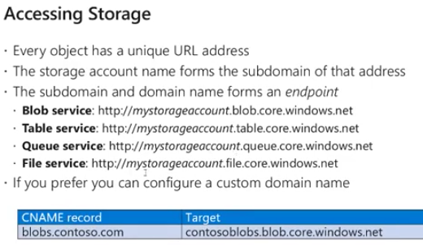

* + Can add this from the "custom domain blade" in the storage account

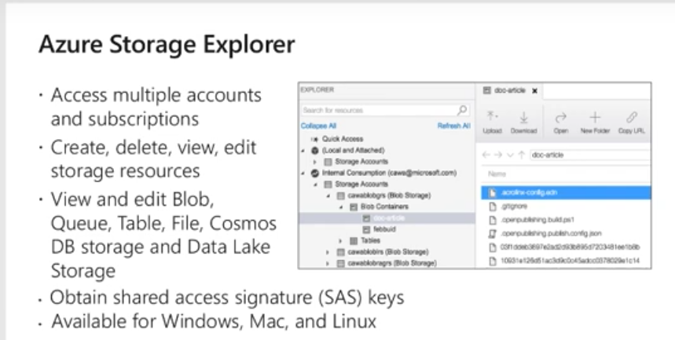

* + - Can log in using the Account username and password
      * But there can be users who don’t have accounts in the Azure account
        + Connection string

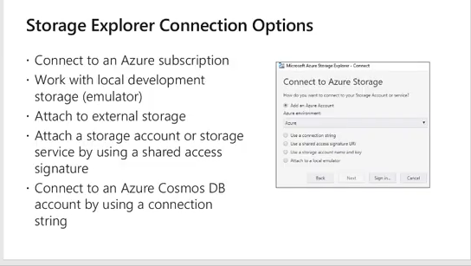

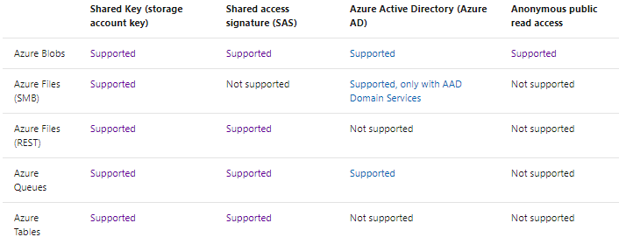

## Blob Storage

[Azure AZ-103 Exam Prep M3-L2](https://www.youtube.com/watch?v=MZT9rTuvFzQ&t=1439s)

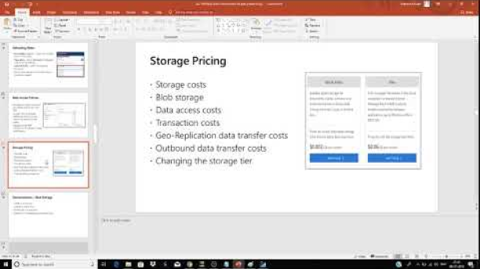

<https://docs.microsoft.com/en-us/azure/storage/blobs/storage-blobs-introduction>

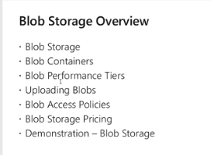

### Intro

* + - Like Google Drive, one drive
    - 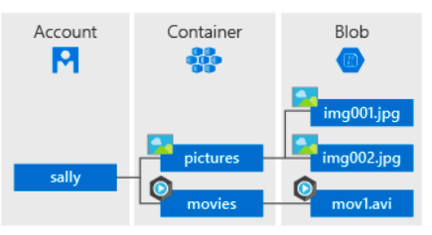
    - Uses
      * Serving images or documents directly to a browser.
      * Storing files for distributed access.
      * Streaming video and audio.
      * Writing to log files.
      * Storing data for backup and restore disaster recovery, and archiving.
      * Storing data for analysis by an on-premises or Azure-hosted service.
    - Storage Account > unlimited containers | Container --> unlimited blobs
    - Controlling blob access

|  |  |
| --- | --- |
| Private blobs | No public access |
| Blob Access | Public access for blobs. But not the containers |
| Container access | Has full public access |

### Types of blobs

|  |  |
| --- | --- |
| **Block blobs** | Stores **text** and **binary** data, up to about 4.7 TB. Block blobs are made up of blocks of data that can be managed individually. |
| **Page blobs** | store random access files up to 8 TB in size. Page blobs **store virtual hard drive (VHD) files and serve as disks for Azure virtual machines.** For more information about page blobs, see [Overview of Azure page blobs](https://docs.microsoft.com/en-us/azure/storage/blobs/storage-blob-pageblob-overview) |
| **Append blobs** | Similar to block blobs, optimized for **append operations (Frequent writing)**. Append blobs are ideal for scenarios such as logging data from virtual machines. |

* Accessing the blogs - Connection string
  + Connection string gives full read-write access to the storage account to anyone who has that
  + To control this use SAS

* BLOB access tier
  + Different than the storage account performance tier. (hot, cool) --> this defines the physical storage type and cannot be changed after you create

|  |  |
| --- | --- |
| **Storage ac access tier** | * + - 1. Decides the physical storage. Magnetic vs SSD       2. Cannot be changed after the storage account is created |
| **BLOB access tier** | * + - 1. Doesn't decide the physical storage       2. Can be changed at anytime       3. Benefit: In a hot storage access account, you can create cool or archived tier blobs to save costs. |

|  |  |
| --- | --- |
| **Hot tier** | Frequent access |
| **Cool tier** | Infrequently accessed  Stored for at least 30 days |
| **Archived** | Several hours of retrieval latency  Stored for at least 180 days |

* + Even if you selected hot in the storage account creation, for certain files you can't select cool or archived.

* Container access

|  |  |
| --- | --- |
| **Private** | "the specified resource doesn’t exist". No private access |
| **Blob only** | Only for the individual blob (Data), public access is given |
| **Container public access** | Container and everything inside is publicly accessible. Can list the blobs in the container. But cannot list the containers in the storage account. |

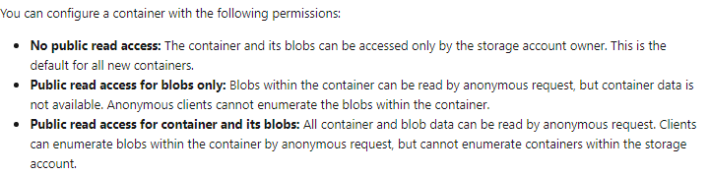

* Blob Storage pricing can vary depending on
  + Region
  + Storage Type - Blob, File, Queue, Table
  + Type of File - Block, file, append
  + Data Access
  + Data transaction - Only egress is charged. Ingress is FREE
  + Geo-replication
  + Outbound data transfer to another region
  + Changing the storage tier

## Azure file storage

[Azure AZ-103 Exam Prep M3-L3](https://www.youtube.com/watch?v=YKHRVNf4AMo&t=11s)

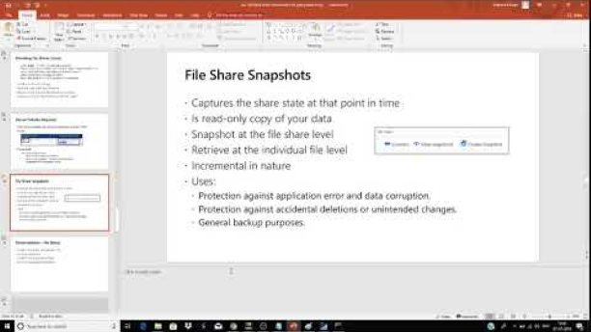

### Introduction

* + Managed files share in the cloud that can be accessed via SMB
  + It is a Data location in the cloud
    1. Accessible via SMB protocol
    2. Can be accessed by anyone who has mounted the file share in the system
    3. With the purpose of providing data to the cloud in lift and shift manner

### Benefits

* + Can be used to replace legacy file share systems including on-premise
  + Lift and Shift
  + Azure file sync
  + Shared applications
  + Diagnostic data
  + Tools and utilities
* 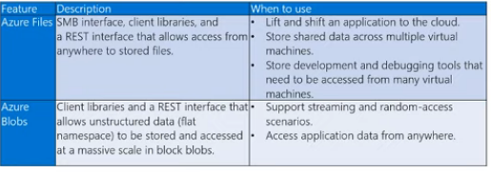
  + E.g. Developers accessing shared files by mounting a file share within their machines
  + In blob - you can create different folders and give different access to different folders. In azure file share, when someone mounts the files, he has access to all the files.

### Creating a file share

* + In the storage account, in the files blade, create the file share

### How to Access --> Mount

* To access file shares, must mount this. Into computer. The mounting code is there when you click connect.
* Copy-paste the PowerShell or CMD of the client machines.
* What is required to create an access
  + Mapping drive letter
  + UNC path
  + Account user
  + Storage account key
  + Port 445 to be open

### Secure transfer required (HTTPS traffic only.)

* Require API's to call the storage account in HTTPS, enable this option
* Only available when the default domain name is used. [https://Core.windows.net](https://core.windows.net).

### File share snapshot

* + Normal Backup
  + Accidental deletion
  + Versioning in case any data corruption happens
  + Create snapshot - File share --> create a snapshot
  + View snapshot
  + 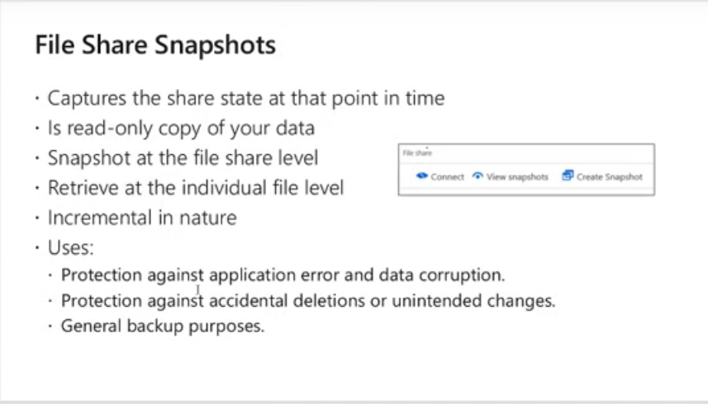

### Extra azure file sync

For a file share to be mounted the port 445 needs to be open. When it is closed, file sync can be used to access the file share.

1. Creating storage File share
   1. In the resource, group create a storage group (location x)
   2. Create a File share
      1. This can be linked to an any computer as a network drive
      2. Click connect 🡪 run the script in the power shell
2. Create storage sync service and file sync group
   1. In the resource group create a Storage sync service (Location x)
   2. Create a sunk group (Adds the cloud endpoint)
      1. Storage group, and file share as the previous step
      2. The created file sync should be in the same region as the targeted storage account to be
      3. 

1. Create the VM and register with File sync group
   1. Create VM
   2. In server manager 🡪 disable “IE Enhanced security configuration”
   3. Download the “Axure storage sync agent” and install
   4. Log in in the azure storage sync agent
   5. Register computer with the file sync group
      1. Subscription, Resource Group, Storage Sync service
   6. Now we have a VM that is ready to sync with the Storage sync service
   7. This acts as the Server End point
   8. Same file share can have multiple server end points
2. Add the cloud end point to sync the server.
   1. In the sync group of the portal 🡪 add server end point
   2. Select the VM and give a path with an available drive (folders will be automatically created within the drive)
   3. Now they will sync

## Storage Security

* [Azure AZ-103 Exam Prep M3-L4](https://www.youtube.com/watch?v=Y8o2Ni3SiNo&t=401s)

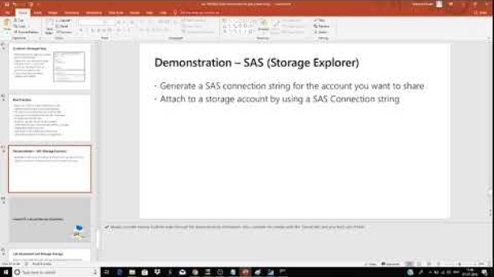

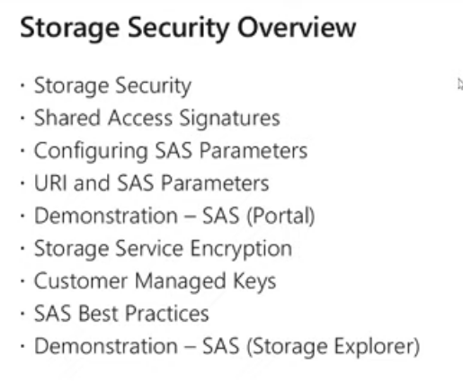

### Introduction - Storage security

* + Microsoft automatically encrypt all data in storage account by default
  + Access control - Authentication with azure ad & RBAC
  + Encryption for data in transit by client-side encryption, https or SMB 3.0
  + Axure disk encryption (disk is automatically included in a storage account)
  + SAS to delegate access
  + Shared key -
  + Anonymous access to containers and blobs

### SAS

* + One way to share storage account access is via Access key --> but shares the full access to the account
    1. Solution - SAS, specifically get access to blob, file, queue or table.

|  |  |
| --- | --- |
| * Account level SAS | * At the account level. (In the storage account, SAS Blade) |
| * Service level SAS | * At the service level. Gives access to Blob, file queue or table service. |

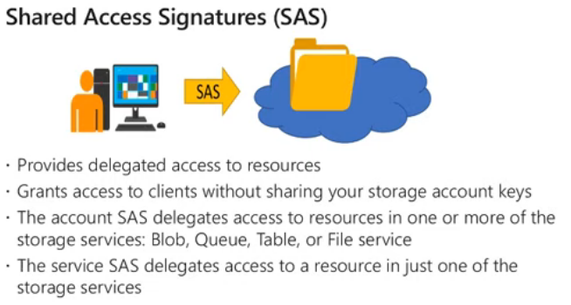

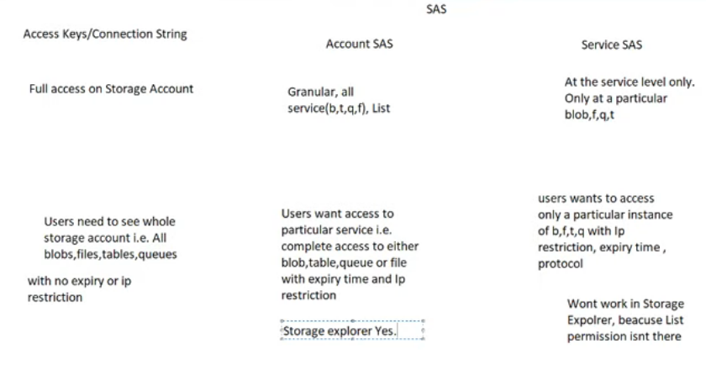

* Storage encryption
  + Anything put in storage account is automatically encrypted
  + Can encrypt using customer keys
* Stored Access Policy
  + Only way to revoke, change expiry of a SAS. Cannot delete SAS
  + applied at the service level
  + Acts at the container level
  + Overrides all SAS policies and the expiry times
  + A stored **access policy** provides an additional level of control over service-level **shared access** signatures (SAS) on the server side.
* Best practices of storage security

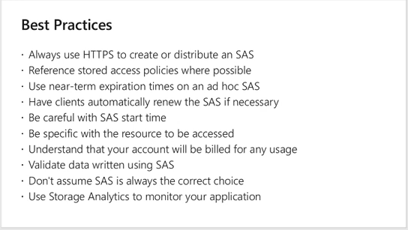

[Azure AZ-103 Exam Prep M3 Azure Storage Review Questions](https://www.youtube.com/watch?v=Lv1fSnlzMAM)

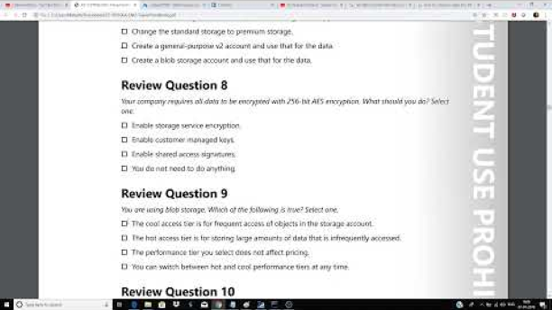

# 4 Virtual networking

[Azure AZ-103 Exam Prep M4-L1 Azure Networking](https://www.youtube.com/watch?v=tSj0_ffq7eg&list=PL2cpErdp4pbDBl9J7rts6VNwr3U-l-LXG&index=13&t=0s)

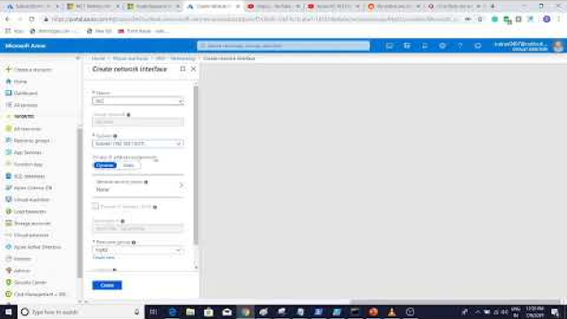

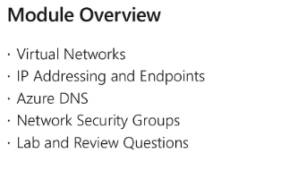

* Azure network provides
  + Virtual network
  + Load balancer
  + Dns
  + Application gateway
  + Vpn gateway
  + Express route
  + CDN
  + Traffic manager
  + Network watcher

## Virtual Networks

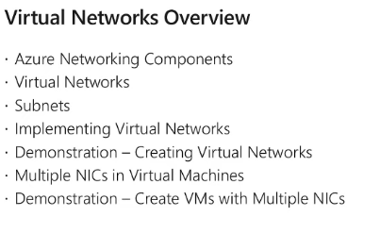

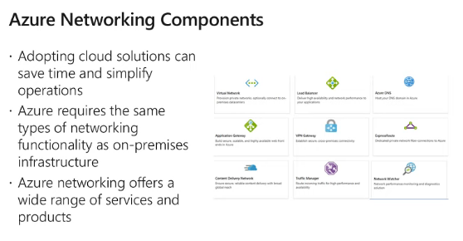

### Virtual Networks

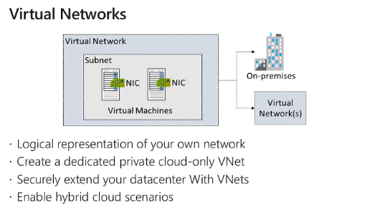

* + What is VNet
    - Logical representation of IP address range
  + Why NIC
    - IP address is attached to the NIC. NIC is an independent resource in NIC
  + Dedicated private cloud-only network
    - If you want to connect the on-premise data center, technologies like S2S VPN and Express Route are used

### Subnets

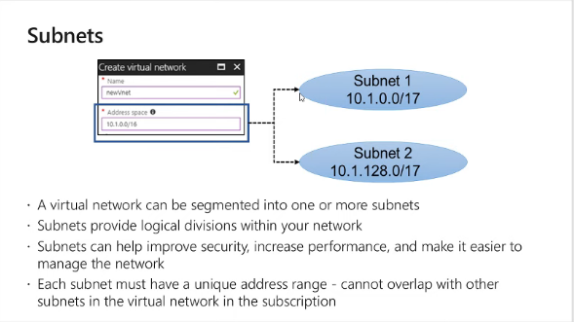

* Each subnet within a virtual network can by default can communicate with each other. E.g. Below, app subnet can communicate with web subnet.

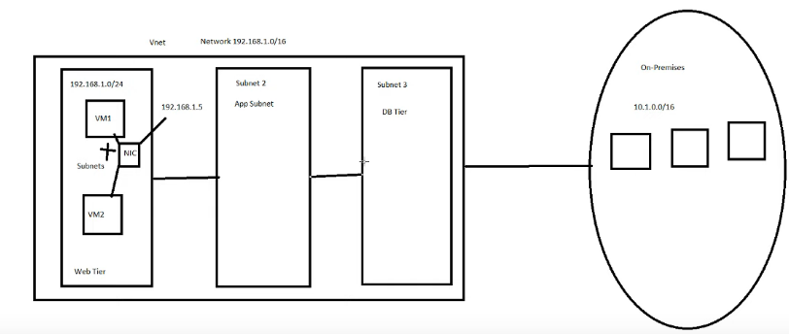

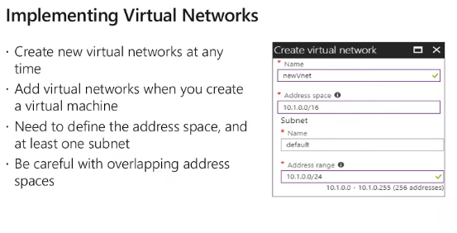

### Creating vnet

* + Type virtual network and create new
    - Name
    - Address Space
    - Subscription
    - Resource Group
    - Location
    - Subnet name
    - Address range
    - DDOS Protection
    - Service endpoint
    - Firewall

* With powershell
  + 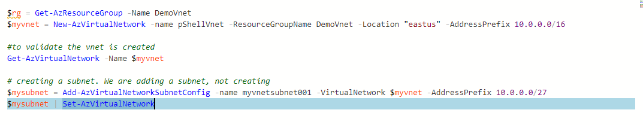
* Demo - A virtual machine can have multiple NICs
  + Manage network traffic,
  + optimize or isolate traffic (zscaller or Cisco equipment)
  + You cannot attach the second NIC for a VM that has a single NIC when the VM is up. Must shut down it.
    - However, if it has already more than 1, then more can be added, because the network will be active with one.

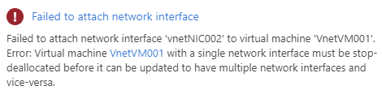

## IP Addressing and Endpoints

[Azure AZ-103 Exam Prep M4-L2 IP Addressing and Endpoints](https://www.youtube.com/watch?v=Q_YgPZpYnNw&list=PL2cpErdp4pbDBl9J7rts6VNwr3U-l-LXG&index=14&t=0s)

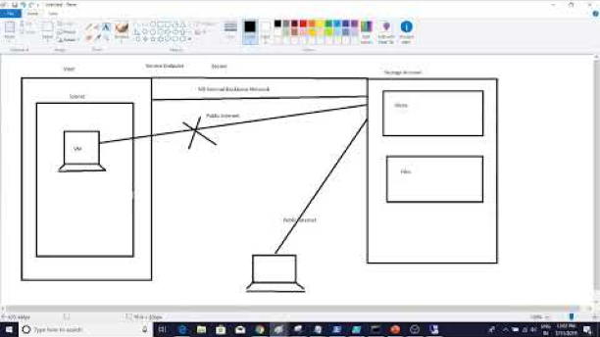

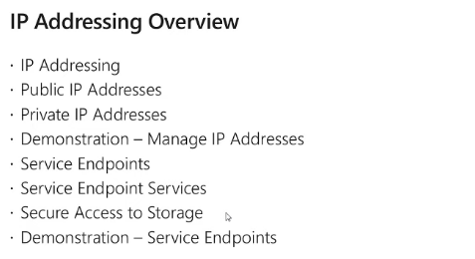

### IP Addressing

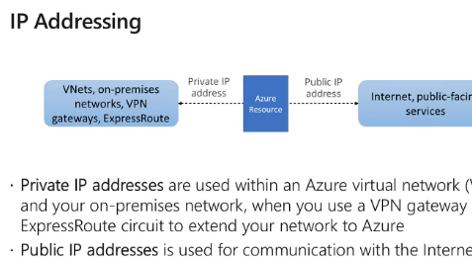

* Two types of IP address
  + Private - communicate internally
  + Public - communicate with Internet work
* Public IP Addresses are independent resources
* Can be mapped in to
  + NIC
  + Load balancer
  + Application Gateway
  + VPN Gateway

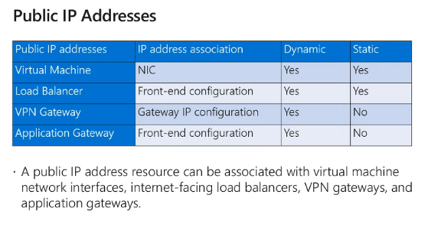

* Creating public ip address
  + IP version - if you select both, 2 ip addresses will be created
  + SKU
    - Defines IP Security, ip address assignment
    - Basic - can create dynamic or static, can Attached to all 4
    - Standard - Cannot create static IP, therefore cannot assign to VPN GW & APP GW
  + Name
  + IP Assignment
  + Idle timeout
  + Dns name label
  + Subscription
  + RG
  + Location

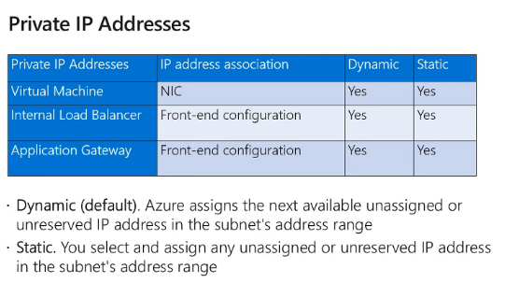

* VPN gateway always uses a public IP address, as it uses internet
* Static Address assignments
  + If you are running and important service DNS or Domain controller
  + When the ip address should not change
  + Public static is More expensive that public dynamic
  + If you are using ip based SSL

### Endpoints

* Concept
  + If you want to securely access, MS service from an Azure subnet, using MS internal backbone network, you must create a service endpoint.
  + Then you can limit the access to the service, only to the relevant subnet. You create a firewall+virtual network rule at the storage account side, allowing only the relevant subnet of the vnet where the end point is created.

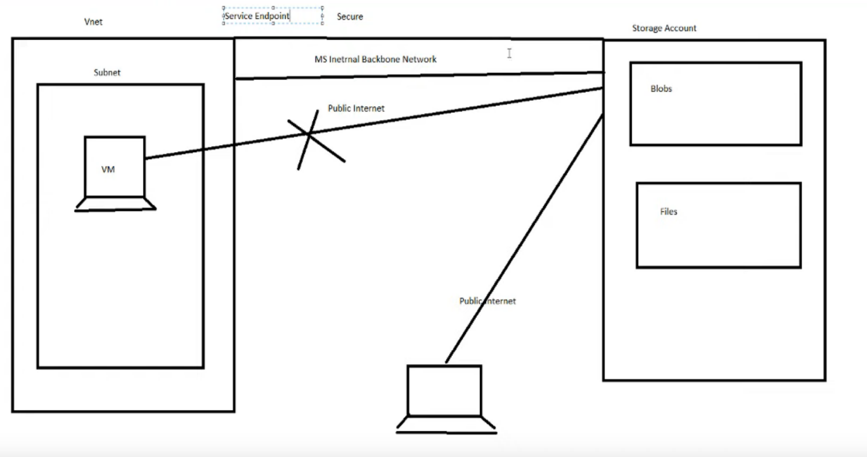

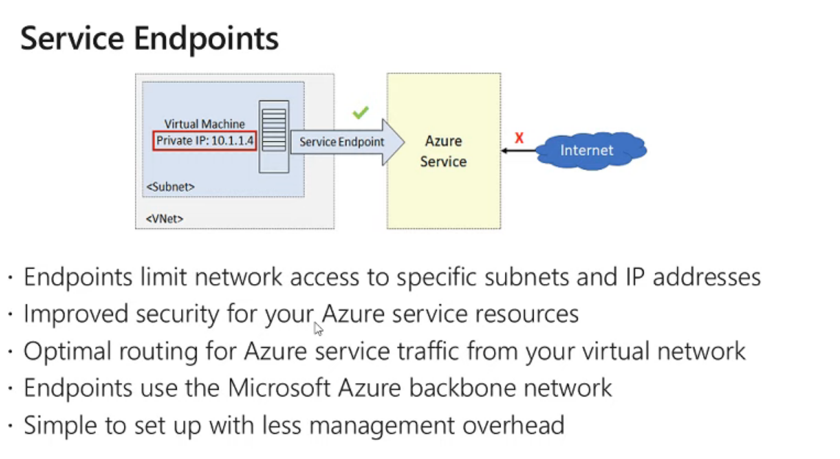

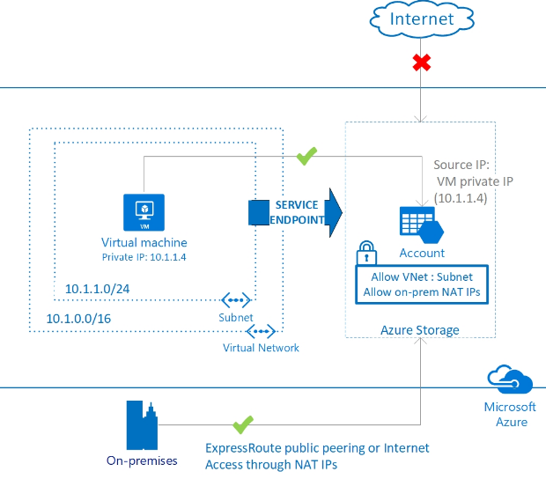

* EXTRA - For create connectivity between two **vnets** via Microsoft backbone, vnet peering is used.
* Creation of a service endpoint
  + 1. Go to virtual network > Service endpoints blade
    2. Select the service - In this example Microsoft.storage
    3. Policies - No part of this course
    4. Subnet - Add the subnets that you want to give access to storage
  + However, now all subnet traffic will go through the Microsoft backbone. But other public IP's can access too
    1. To block other ip, go to storage account > Firewall & Virtual networks > add the virtual network

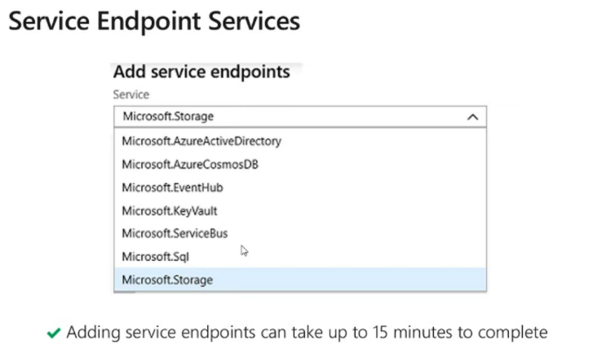

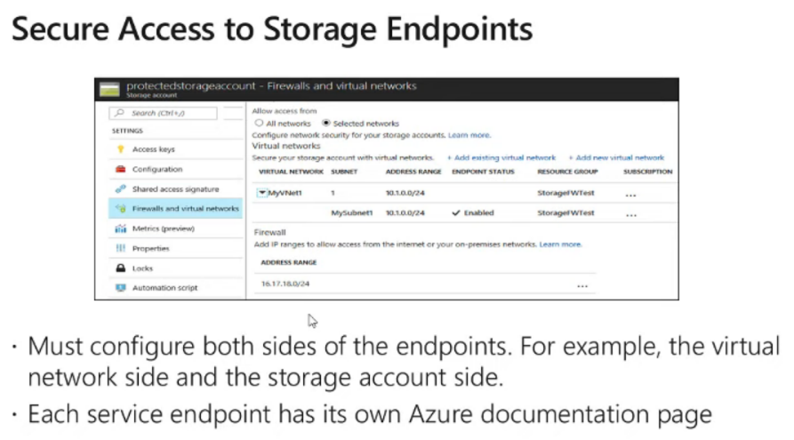

* + Create a service end point at the vnet.
  + Create firewall and Virtual network rule at the storage account.
* <https://blog.coeo.com/azure-service-endpoints>
* What happens when a service endpoint is created?
  + The traffic from the subnet to the selected service will flow through the Microsoft internal network. (azure fabric). New route is added in the subnet.

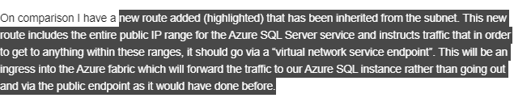

* But this will not block the access to the service from the internet. For that a firewall rule is applied at the service.

## Azure DNS

[Azure AZ-103 Exam Prep M4-L3 Azure DNS](https://www.youtube.com/watch?v=_x4Hv01AT1c&list=PL2cpErdp4pbDBl9J7rts6VNwr3U-l-LXG&index=15&t=0s)

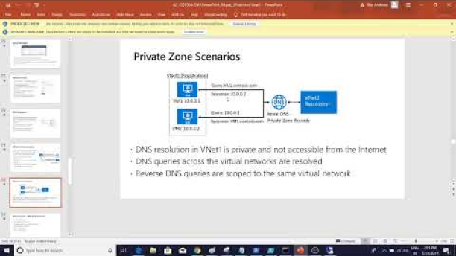

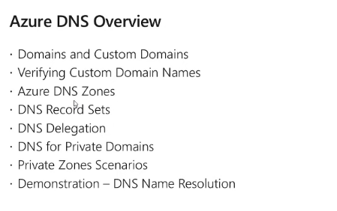

* By default, the domain will be creating from the owner’s login and onmicrosoft.com
  + All the users added to the active directory will also have the same.
  + 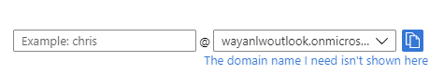
* Changing onmicrosoft domain to a custom domain
  + Axure active directory > custom domain names > add
  + You will have to add the TXT or MX record to the DNS hosting

### Azure DNS zone

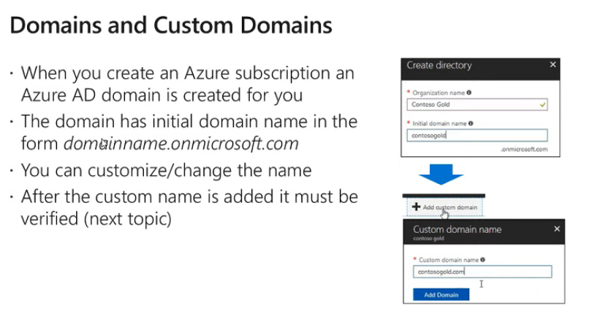

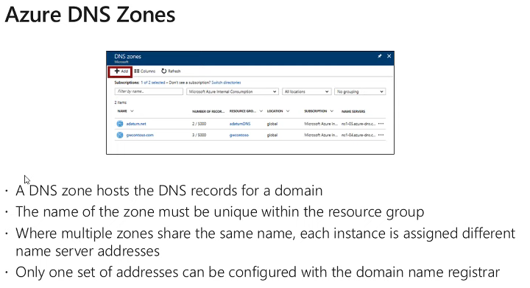

* A DNS zone is used to host the DNS records for a domain. To start hosting your domain in Azure DNS, you need to create a DNS zone for that domain name. Each DNS record (A, MX, NS etc.) for your domain is then created inside this DNS zone. For example, the domain 'contoso.com' may contain several DNS records, such as 'mail.contoso.com' (for a mail server) and '[www.contoso.com](http://www.contoso.com)' (for a web site).

### DNS Record set

* 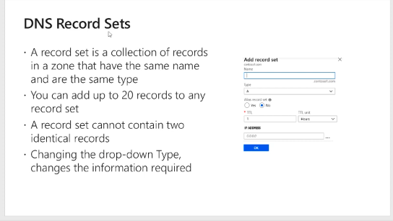

* 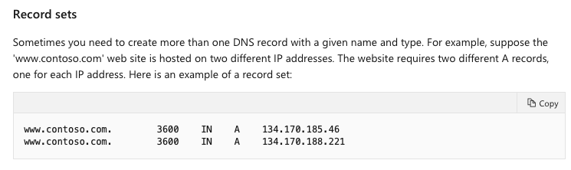

### DNS Delegation

* + 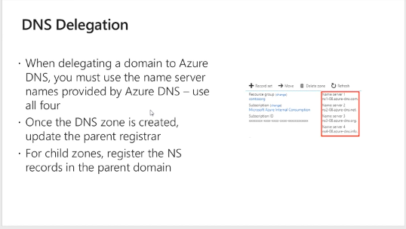
  + Azure DNS allows you to host a DNS zone and manage the DNS records for a domain in Azure. In order for DNS queries for a domain to reach Azure DNS, the domain has to be delegated to Azure DNS from the parent domain. Keep in mind Azure DNS is not the domain registrar.

### Private DNS Zone

* + 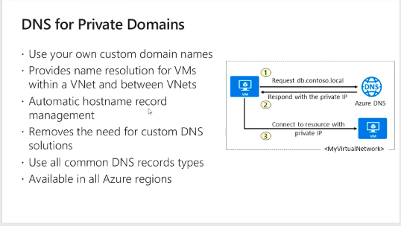
  + Provide a DNS envt. Between different vnets
  + 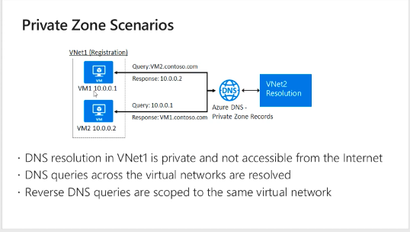
* How to configure DNS
  + Create a DNS zone in azure for the domain name
  + Find the name servers from that
  + Create name server delegation
    - Insert the azure NS records ns1-04.azure-dns.com In your domain name registrar. This is the authoritative ns records.
    - Now the domain registrar will forward DNS resolutions to azure dns
  + Create the record sets in Azure
    - A record direct to the webserver

## NSG

* + [Azure AZ-103 Exam Prep M4-L4 NSG](https://www.youtube.com/watch?v=OnSpURUfQhM&list=PL2cpErdp4pbDBl9J7rts6VNwr3U-l-LXG&index=16&t=0s)

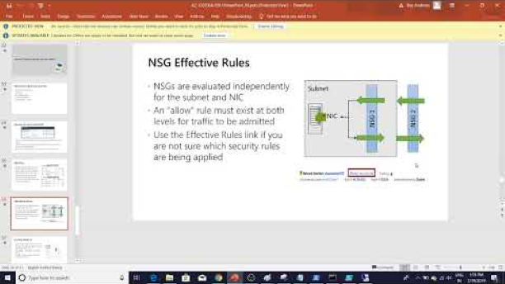

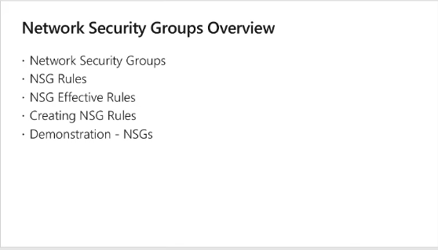

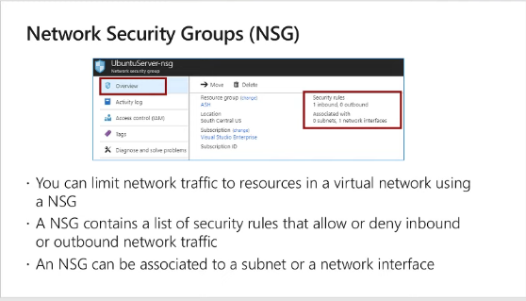

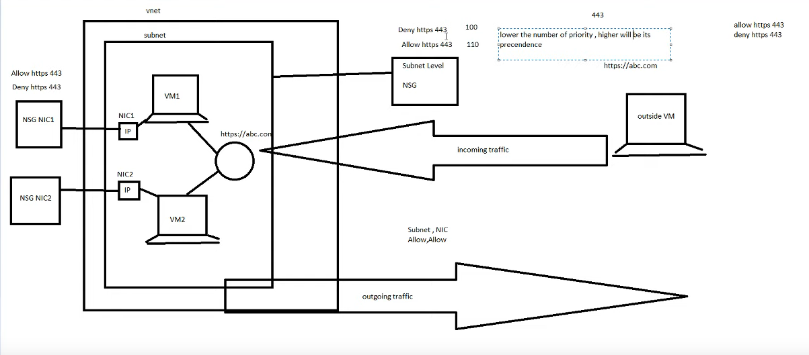

* NSG is like a firewall, you can define rules to allow or deny traffic
* VM > networking > Select the NGS OR select the NSG from the resource group
* 2 levels of NSG's applied
  1. Subnet level - Commonly applied to all VM's in the subnet
  2. NIC level - Applied only to the specific VM
  + For an allow rule to work, it should be the allowed at both subnet and NIC level
  + For a deny rule, it can be configured at any of the levels, depending on the requirement
* To see the actual rules that are applied to your VM, refer NSG effective rules
  + NIC> (suport+troubleshooting) Effective rules

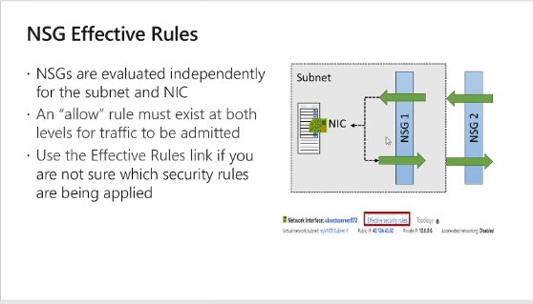

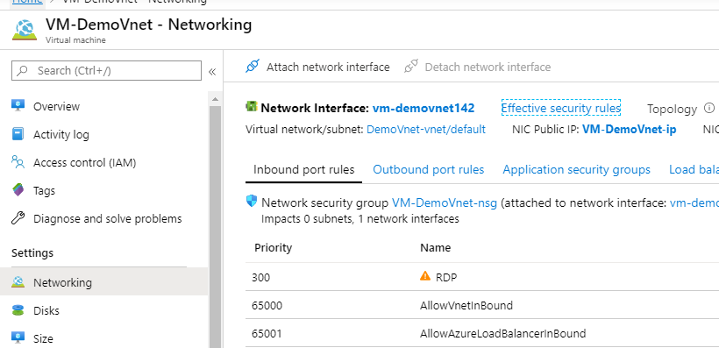

### NSG Rules

* + Cannot delete the default rules. You can apply new rules with a higher priority. I.e. lower value
  + Default Inbound
    1. All traffic within the Vnet is allowed
    2. All load balancer inbound traffic to any destination is allowed
    3. Deny everything else
  + Default outbound
    1. All traffic out to vnet is allowed
    2. Allow internet outbound traffic (to deny this, create a rule with higher priority)
    3. Deny all other traffic
  + 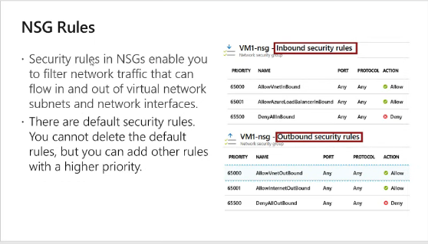

### Demo: go to NSG

* + VM > Networking blade > just above the rules it displays nsg
  + OR directly go to nsg.
  + When creating a vm, nsg is automatically created. Can create an NSG separately too. (If separately created, it will not attach to any NIC)
  + Separately created NSG
    - If attached to the subnet, will applicable for the entire subnet
    - If attached to an NIC, will applicable for the VM only.
  1. Create NSG rules
  2. 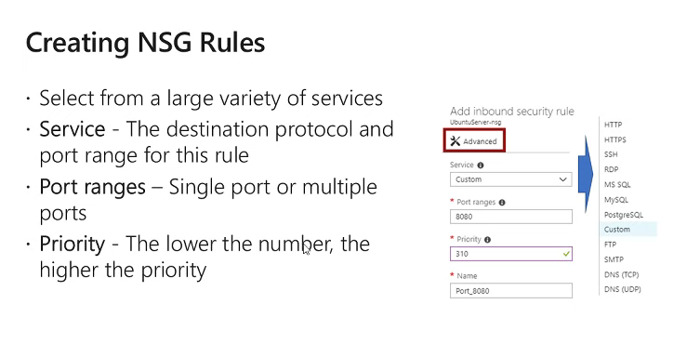

# 5. Inter-site connectivity

[Azure AZ-103 Exam Prep M5-L1 Inter-site Connectivity](https://www.youtube.com/watch?v=BjeWwxIbWww&t=689s)

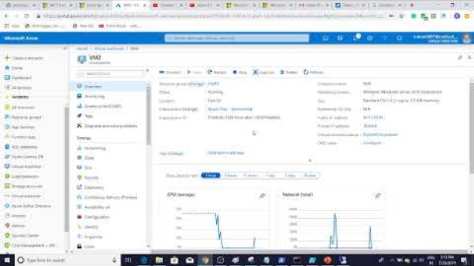

## VNET Peering

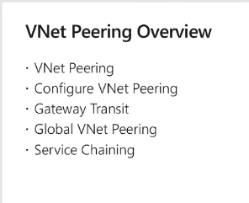

* All VMs within a vnet can communicate with each other.
* VNET peering - to connect two virtual networks together and make them able to communicate with each other as if they are in the same network
* If IP address spaces overlap, they cannot be VNET peered.
* 2 types of vnet peering
  1. Regional Vnet peering - Peered networks are in same region
  2. Global vnet peering - Peered network are in different regions

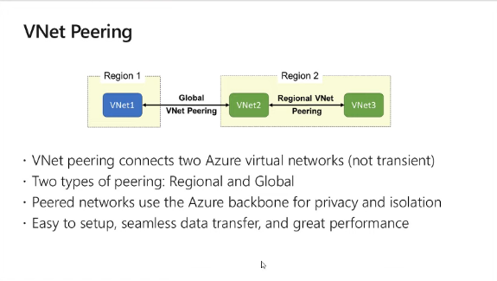

* Vnet peering is not transient - Vnet 1 and Vnet 3 are not peered. In below vnet 1 and vnet 3 are not peered.

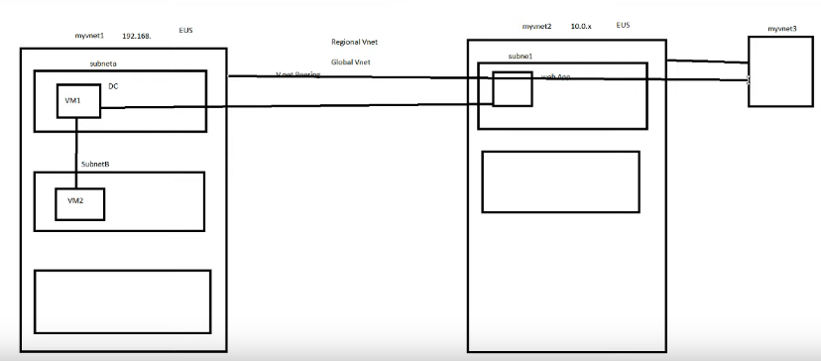

### Create a peering

* + Go to virtual network > peering
    - Name
    - Deployment mode - resource manager (classic is the old version)
    - Subscription
    - Virtual network - select the destination network for peering
    - Name

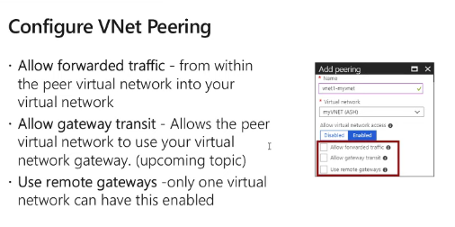

* Virtual network access settings - **allow one-way traffic. By default, both sides are allowed**

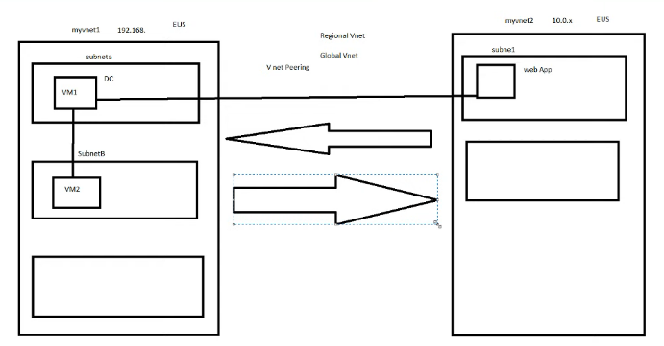

* Configure forwarded traffic settings - **Block traffic originated from other networks which are forwarded by the source vnet for peering.** E.g. If Vnet 1 computer is a webserver and forwards a request from internet for a video from vm A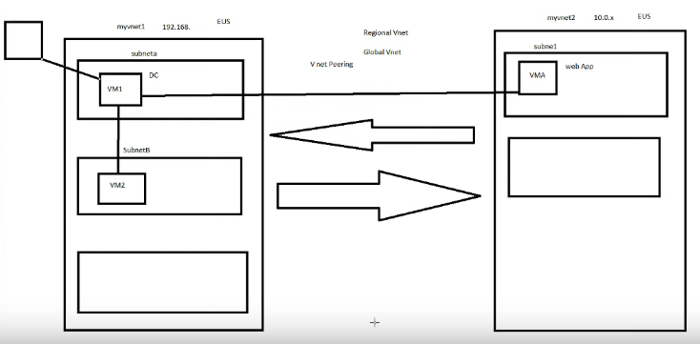
* **Gateway transit -** If you azure is connecting to a -on-premise network you need a vpn gateway. If you are connecting for 2 vnets, you will need two vpn gateways. Gateway transit, one vpn gateway can used to communicate with both vnets.
  + - * In the transit vnet - allow gateway transit
      * In the other vnet - use remote gateway
      * 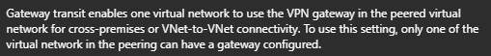

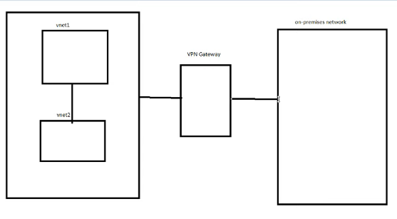

### Gateway Transit

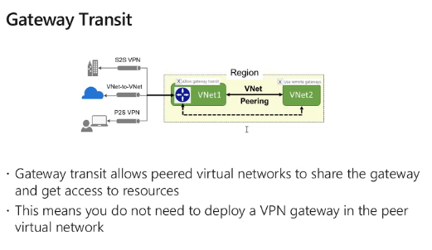

* Gateway transit can only be configured regionally. Not globally.
* When the peering is created the peering is configured in both the networks

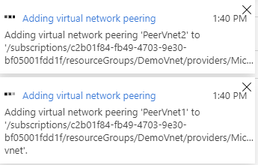

### Global Vnet peering

* 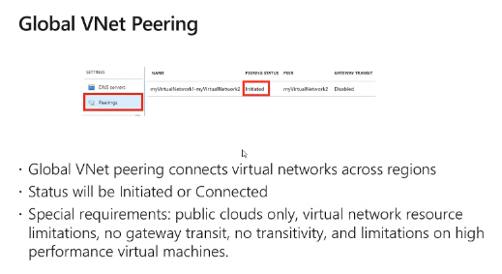
  + This will take more time than regional vnet peering. During the time status will be "initiated"
  + Public clouds only - not working on government and special time clouds
  + Virtual network resource limitation - e.g. Cannot access a load balancer in a different vnet
  + Gateway transit doesn’t work
  + No transitivity
  + Limitations on high performance VMs

### Service chaining

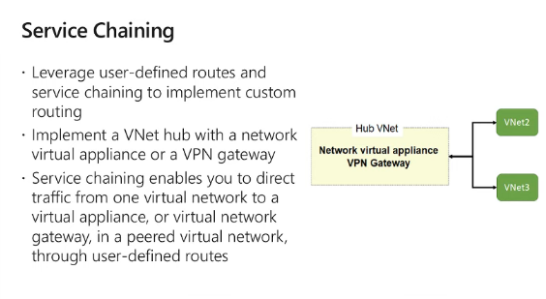

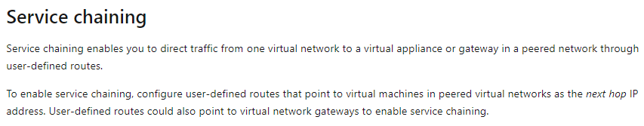

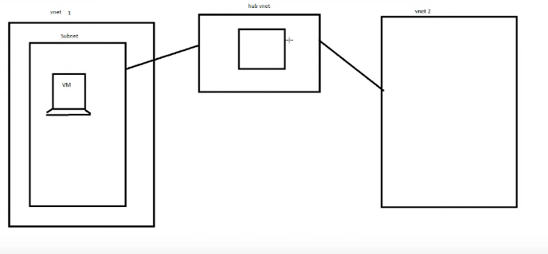

* If you are connecting vnet to a network appliance in another network, with service chaining you can direct traffic via user defined routes. UDR
* Instead you can create a hub vnet where traffic from both vnets will traverse through it.

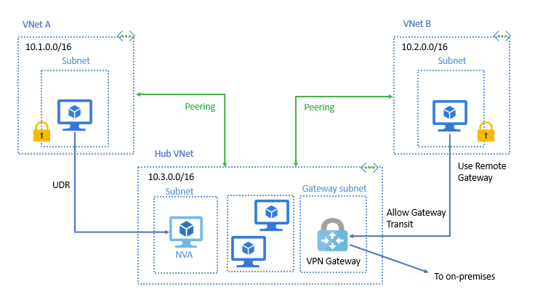

## Vnet-to-Vnet Connections

[Azure AZ-103 Exam Prep M5-L2 VnetToVnet Connections](https://www.youtube.com/watch?v=wMaKJk-5j1o)

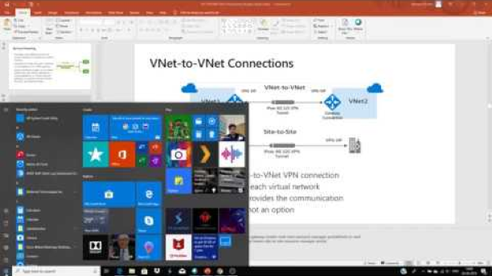

* Vnet peering and global vnet peering allow two vnets to work as the same vnet. What is vnet-to-vnet connections
  + Those days when global vnet peering was not there, only way to connect two vnets in different regions was vnet-vnet connections
  + Now that we have global vnet peering, why is vnet-vnet connection are still there
    1. Backward compatibility. Gvnet peering, is a new concept
    2. Vnet-vnet connection is better with encryption
* Vnet-vnet the vnets can be
  + From different regions - (*this is an alternative for the global vnet peering)*
  + Both in azure cloud
  + In the same deployment model
  + In different subscriptions

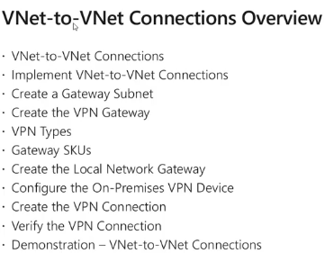

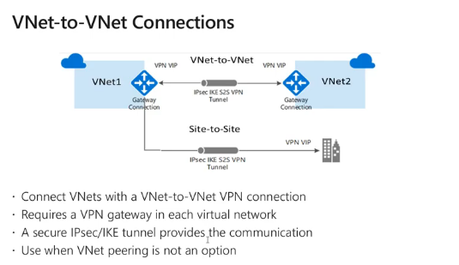

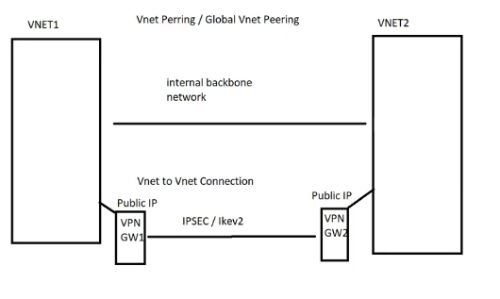

### Create vnet-vnet connection

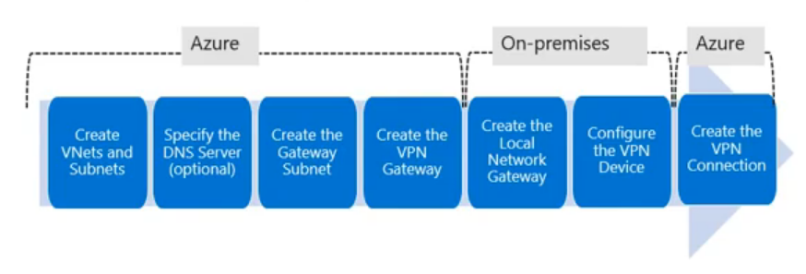

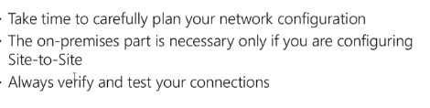

* Create two vnets with non-overlapping ips
* Create gateway subnets in both the vnets
  + Vnet > (settings) Subnet blade > + gateway subnet
  + Subnet should have few ips. Use /28 or /29 subnet
  + 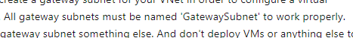

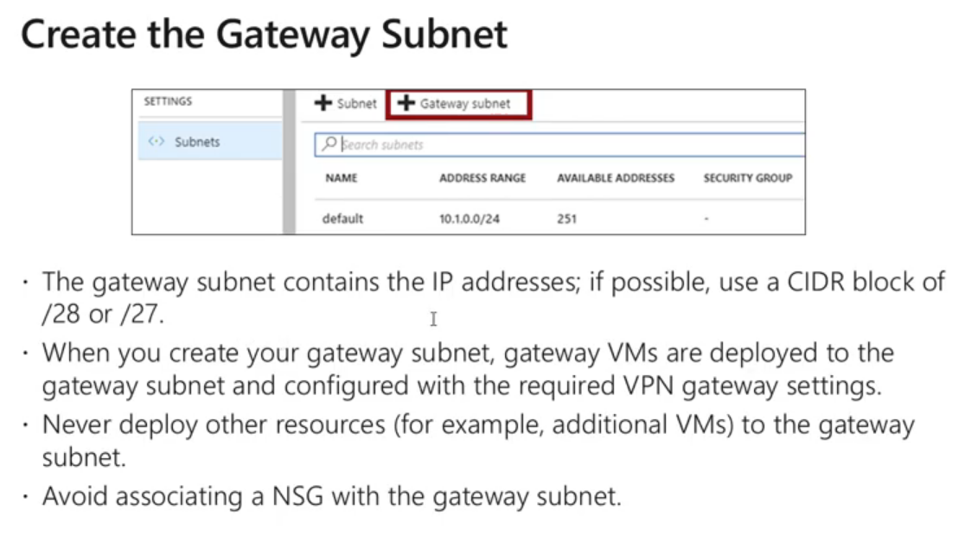

### Create virtual network gateway --> VPN networks takes a lot of time to create (45 mins)

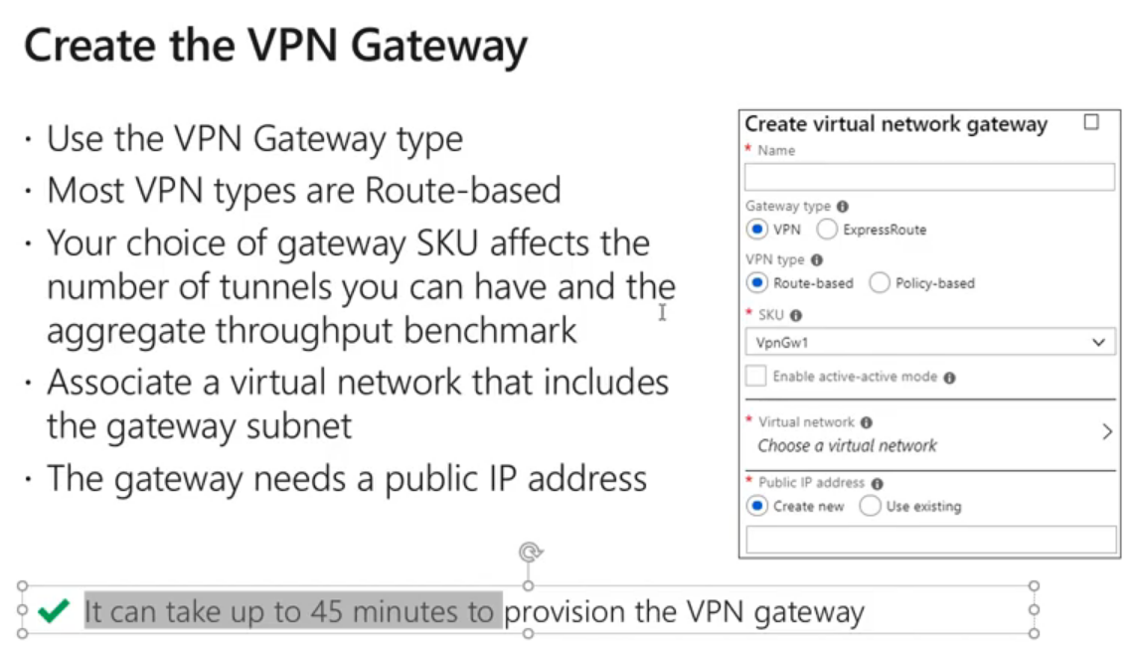

* + Subscription
  + RG  
    Name
  + Region
  + Gateway type
    - VPN
    - Express Route - This is a high throughput low delay dedicated link type
  + VPN type
    - Use route based

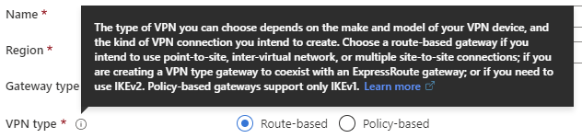

* SKU
  + Note: max BW is 1.25 Gbps in vnet-vnet connection compared the vnet peering which offers very high BW.
  + Defines the features of the gateway
  + 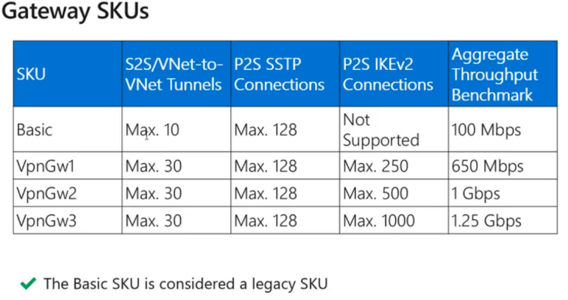
* Virtual network --> Virtual network. Must contain a gateway subnet
  + 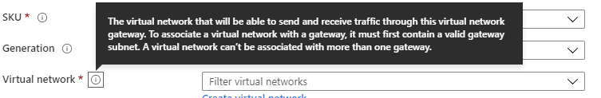

* Connecting azure to an on-premise network
* 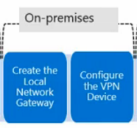
  1. Site to Site connection
     + Instead of the virtual network gateway, this use a local network gateway. Assign the public address of the on-premise end point to this.
  2. Express route
     + Dedicated, Low latency, High BW connection to Azure from premise

### Create local network gateway

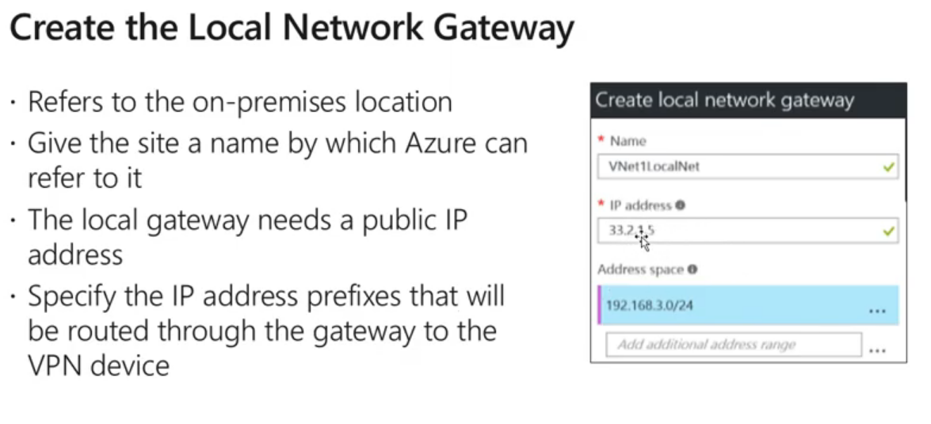

* + - * The public IP assigned cannot be a static one. It is dynamic.

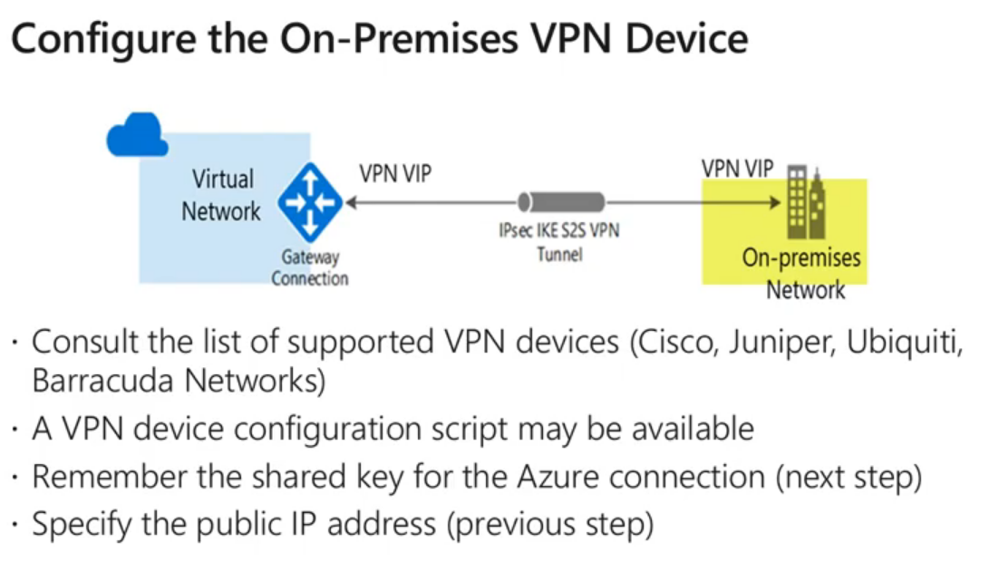

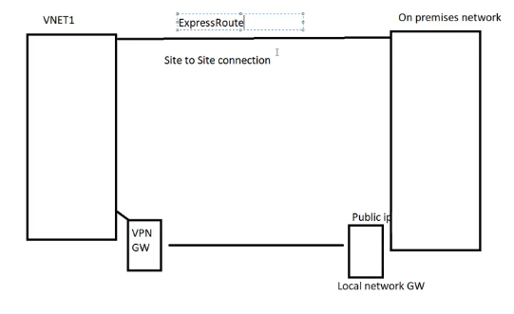

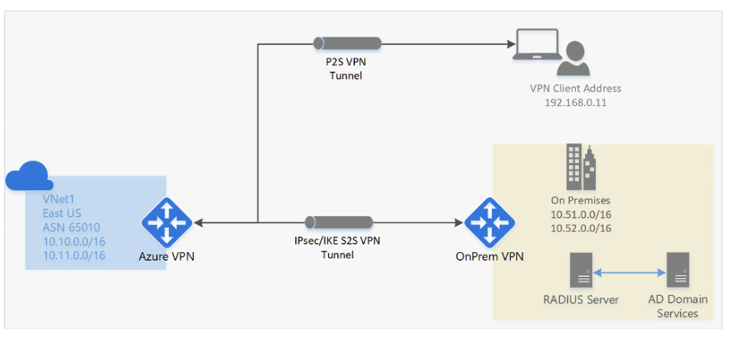

### Create the connection

* 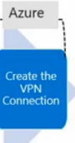

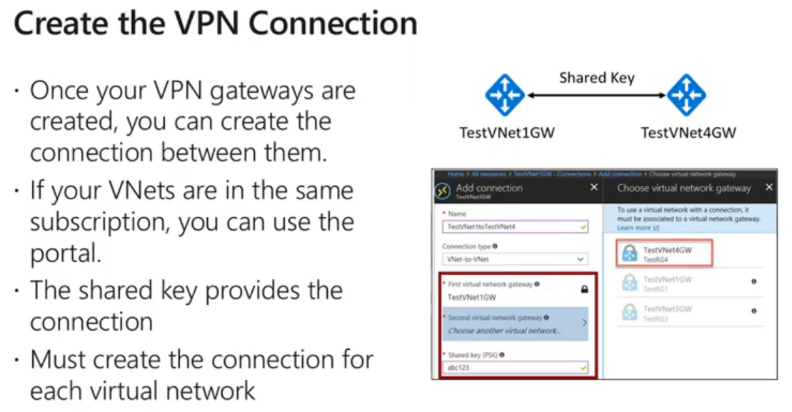

* In the Created VPN gateway > (settings) connection > add
  + Name
  + Connection type: Vnet -vnet
  + Shared key - Can be anything (This should be the same in the other side too)

### Verify the connection

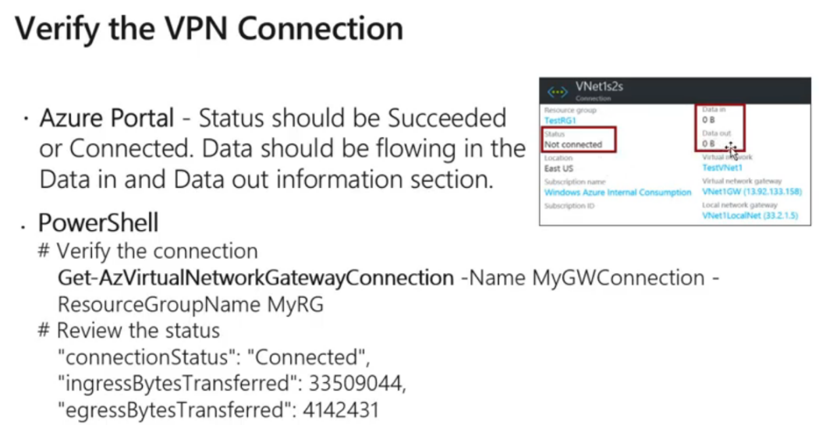

## Express route

* [Azure AZ-103 Exam Prep M5-L3 ExpressRoute](https://www.youtube.com/watch?v=jCclpfy8CkU&list=PL2cpErdp4pbDBl9J7rts6VNwr3U-l-LXG&index=20&t=0s)

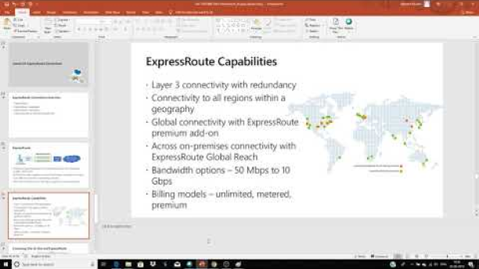

* ER allows you to get a dedicated connection.
* Good for
  + Applications where large amounts of data migration
  + Data migration, business continuity, disaster recovery

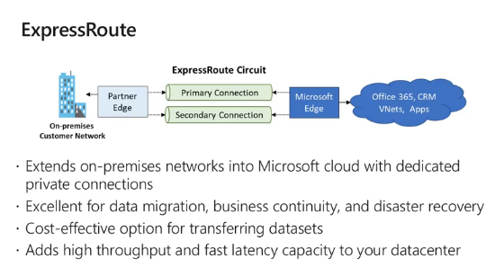

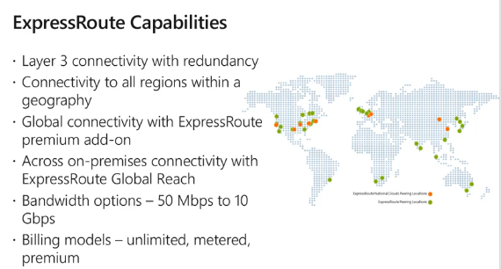

* BW 50 Mbps - 10 Gbps (in vpn the maximum is 1.25 Gbps)
* Billing options
  + Unlimited - Fixed fee. Unlimited data transfer
  + Metered - you pay for ingress and egress
  + Premium - with advanced features

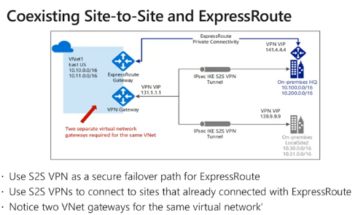

## Review questions

* + [Azure AZ-103 Exam Prep M5 Interstice Connectivity Review Questions](https://www.youtube.com/watch?v=Y1n7ZEhaM6w&list=PL2cpErdp4pbDBl9J7rts6VNwr3U-l-LXG&index=20&frags=wn)

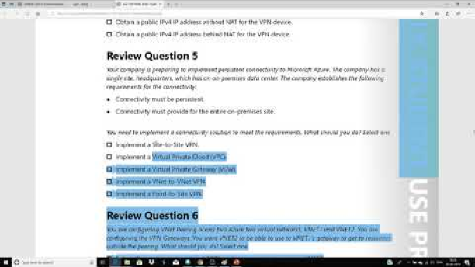

# 6. Azure Monitoring

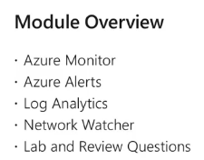

## Azure Monitor

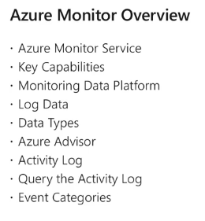

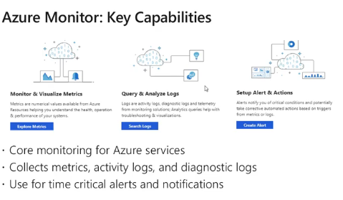

* + - Monitor all azure services data through metrics and logs.
      * Facilitate sending alerts based on certain conditions

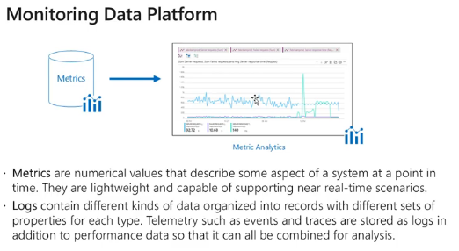

* + - Metric - a numerical value which can be represented in a graph
    - Logs
      * any data which is stored in the form of a log and can be queried later (resource > Activity log)

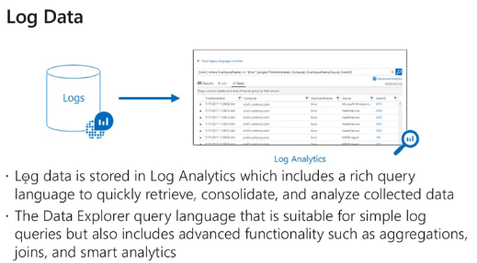

* Log analytics workspace
  + Logs are Stored in **log analytics workspace**. Log-analytics is another azure service which is a part of azure monitor.
    - Log-analytics include rich query language to retrieve, consolidate and analyze these collected data

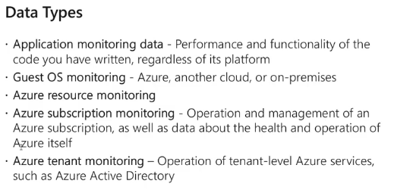

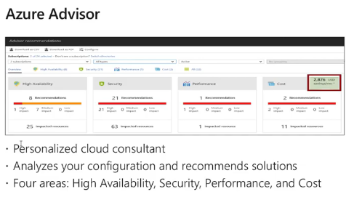

* + Like a consultant
  + New service
  + Works on 4 areas
    1. High availability
    2. Security
    3. Performance
    4. Cost
  + Provides recommendations on how to improve the above

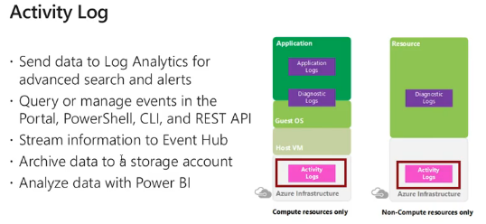

* + Go to any resource or resource group> (Overview)> activity logs OR go to log analytics workspace
  + Activity logs are only stored for last 90 days. If you want more days, logs must be configured to go to a storage account. "Event hub" can be used for his.

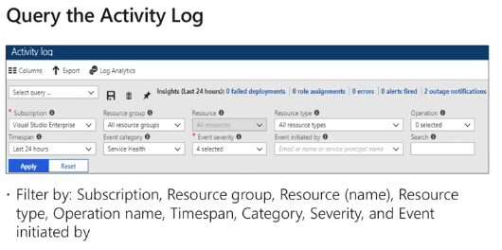

* + - Query using KQL (Kosto Query Language). Like sql.

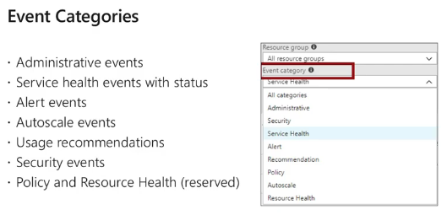

## Azure alerts

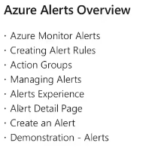

* + Alerts
    - Notification method based on metrics and log data recorded by azure monitor

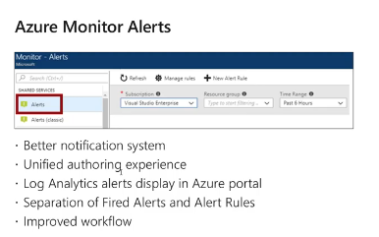

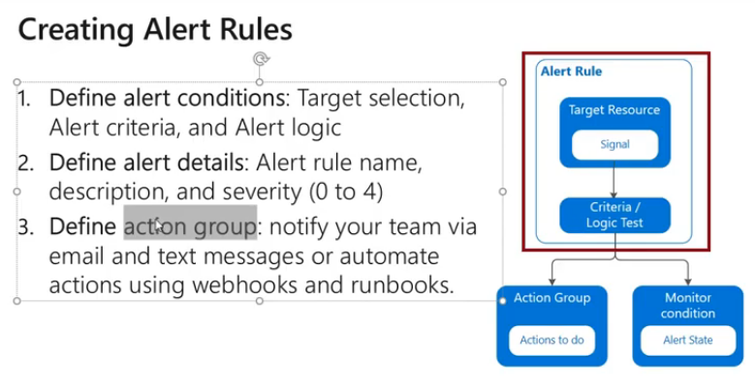

* + Select the resource
  + Select the condition
    - Alert logic
      * Static
      * Dynamic - Azure will learn the usual behavior and throw any abnormal behavior
  + Select the action group (if there is none, create now)
    - Types of notification
      * Run an automation via automation runbook E.g. Alert of >80% CPU utilization, run a run book to increase the size of the vm
      * Azure function - Allows running a code without a server
      * Create IT Service Management ticket
      * Webbooks - Web based end points

* Alerts can be created based on metrics or log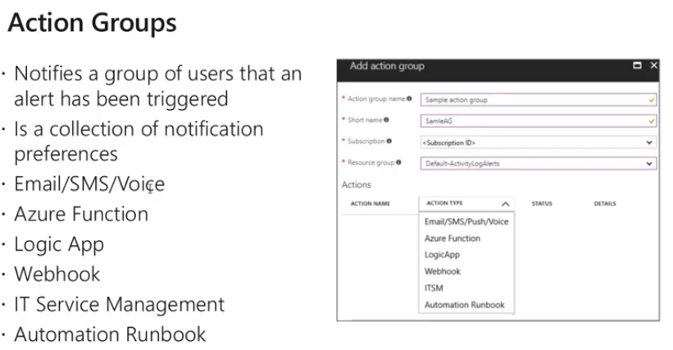

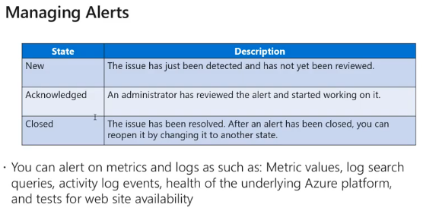

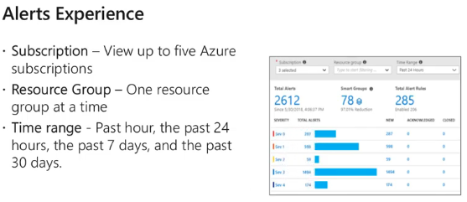

## Log Analytics

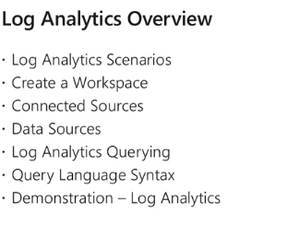

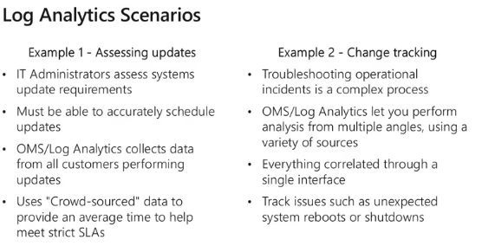

* Create a log analytics workspace
  + Storing my logs and allow querying it
* Demo envt to test your log analytics query
  + <https://www.youtube.com/redirect?event=video_description&v=E30KHgETlIA&redir_token=KWm5R9cW9i7-S_eZHsZx9amNKul8MTU4MTA0NzI5MkAxNTgwOTYwODky&q=https%3A%2F%2Fportal.azure.com%2F%23blade%2FMicrosoft_Azure_Monitoring_Logs%2FDemoLogsBlade>

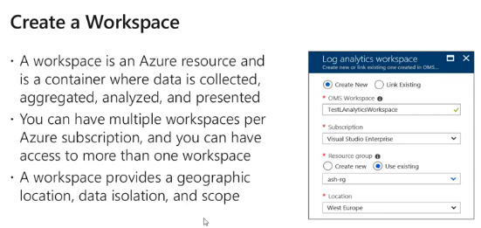

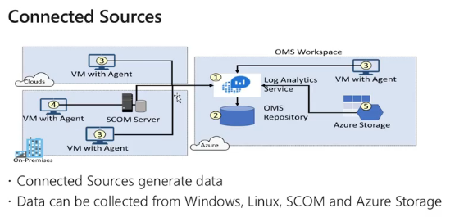

* When creating a VM it asks for storing logs. Asks for a storage account. Connect that storage with log analytics workspace.
* How to see whether the vm is connected
  + Loga analytics > virtual machines
  + If one is connected to the workspace, it should show this workspace. If it is connected to another workspace it will show the other workspace.
  + 
* To connect a VM
  + go to the log analytics workspace >Virtual machines> connect the VM
* To connect a storage account
  + Same as above go to the log analytics workspace >storage accounts > connect the storage account
* To connect to a VM's in on-premise or any other cloud platform
  + Have the scom agent installed in those

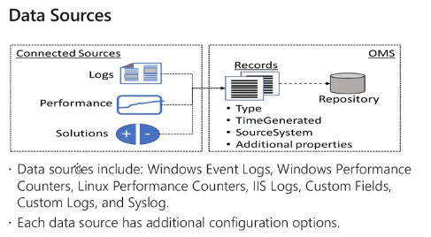

* 'To select the sources for the LA space
  + Loga analytics > advanced settings > select the sources 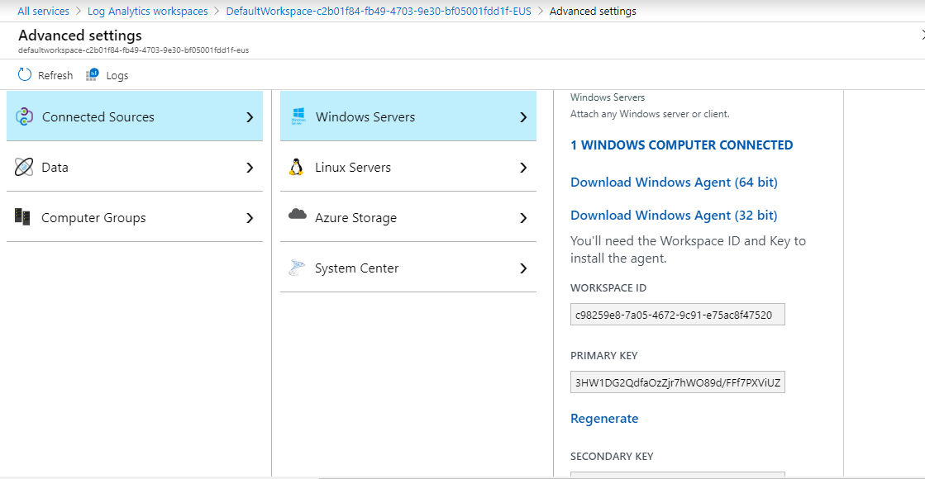

### Query language

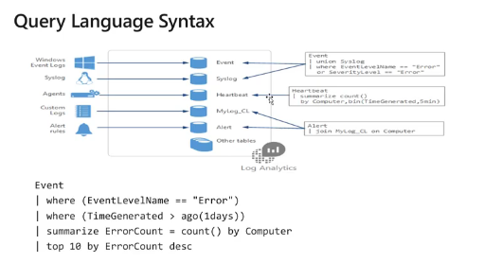

## Network Watcher

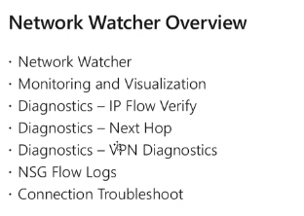

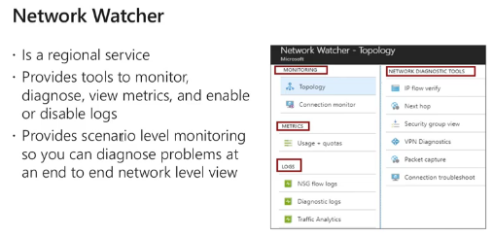

* + One service needs to be enabled for each region
  + Tool to trouble shoot any kind of network issue in your envt.
  + Network watcher > overview --> shows all the regions and enabled and disabled regions. All regions that you are working on is enabled by default. If any is of you are working is disabled, right click and enable it.

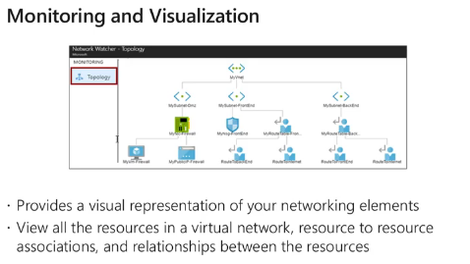

* Network watcher > topology
  + Shows everything within the network topology.

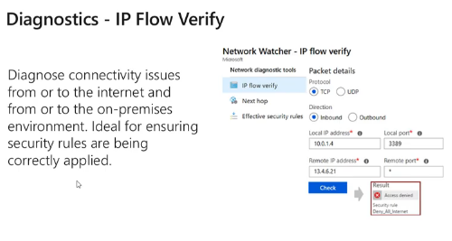

* + Network watcher > ip flow verify
    - Shows everything within the network topology.

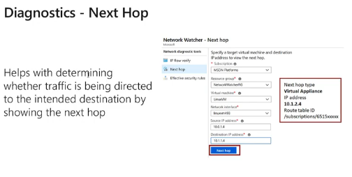

* + If we target our PC as the target - next hope = internet
  + If we target a peered network computer - next hop = network peering

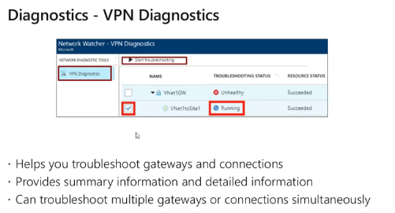

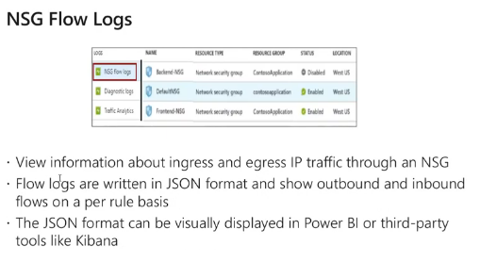

* This is not enabled by default. Must enable it
  + Network watcher > NSG flow log > click on the NSG and enable it.
    - Must select a storage account too
  + Or I think it can be enabled via the NSG directly too.
* When enabled all information regarding inbound and outbound traffic though that NSG
* Shows inbound and outbound traffic for each rule, in a json file.

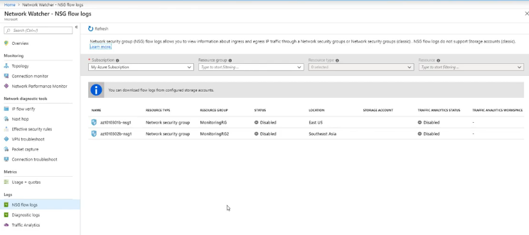

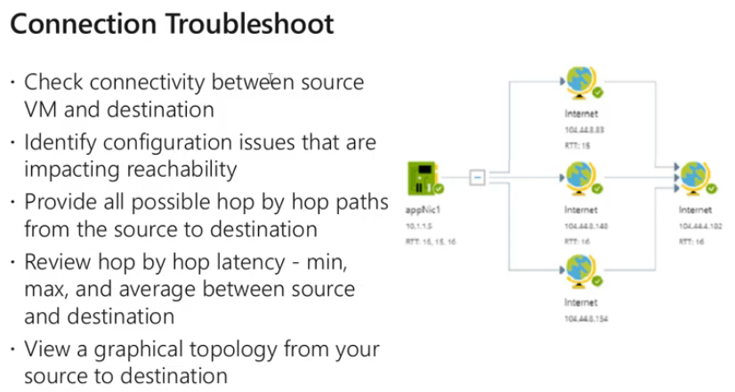

# 7. Data Protection

[Azure AZ-103 Exam Prep M7 Data Protection](https://www.youtube.com/watch?v=HS19z3f_qgE)

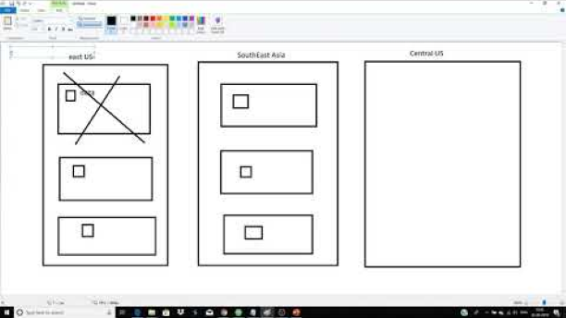

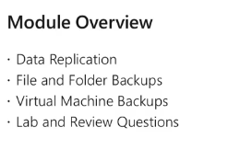

## Data replication (Replication for storage)

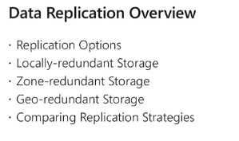

### Replication options

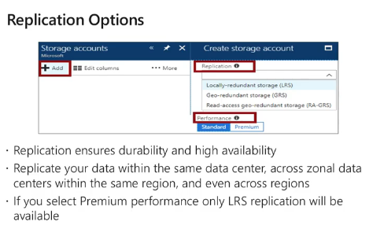

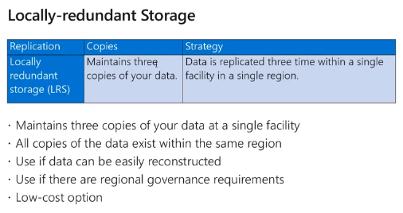

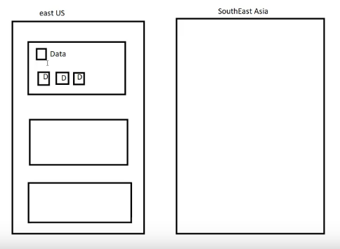

* + If the whole data center is down, data is lost
  + Cheapest replication method

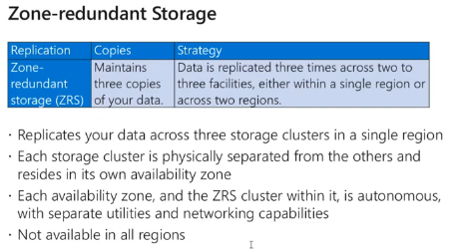

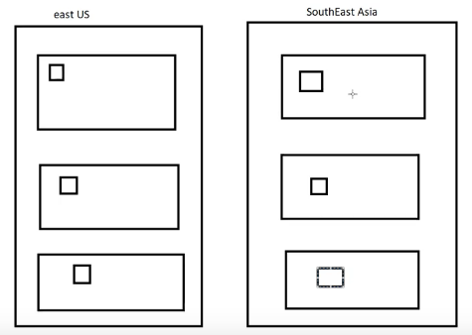

* This is different to VM availability sets. However, in here also, the data is replicated into different fault and update domains.
  + Planned maintenance - MS updates sometimes reboot necessary. Done in one **update domain** at a time
  + Unplanned maintenance - Microsoft expects a fault and preventive maintenance. Live migration is there .no down time. Only slow down. Mostly in a single fault domain
  + Unexpected downtime - Unexpected failure. Down time & reboot. RAM and temp files will be removed.

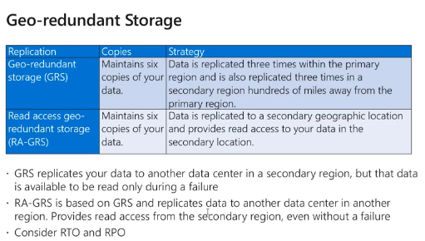

* + Recovery time objective and recovery point objective is high.

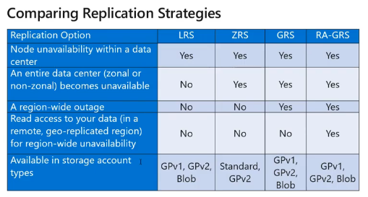

## Files and Folders Backup

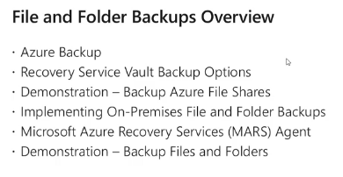

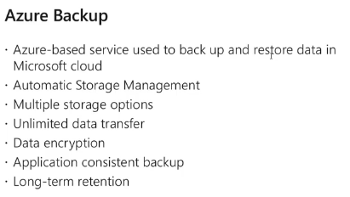

* Multiple storage backup options are available
* Data is always encrypted
* Backups are application consistent. - backup has all the data required to restore it to the exact same condition. (the **application** has been notified and allowed to flush its memory before the copy was taken) Other method is crash consistent

### How to initiate a backup

* Create a recovery services vault
  1. Search for recovery services vault > create
  2. +Backup
     + Workload - Where is the workload running that needs to be backed up
       - Azure / azure stack / On premises /
     + What to backup - what is in there to be backed up
       - VM Disk / Azure File share / SqL server in azure vm
     + Storage account - Where is the workload located. Which storage account?
     + File share to back up
       - Only file shares can be backed up. Blobs, tables, queues cannot be backed up
     + Backup policy - Auto backup maximum is once a day. Manual is 3 times.

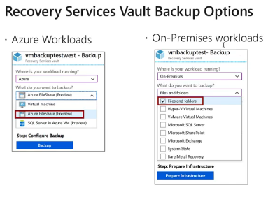

* + First, create a recovery services vault
    - Up to 25 recovery services vaults per region
    - Search RSV and create one
  + To get the information about the backups
    - Vault > (monitoring) backup jobs

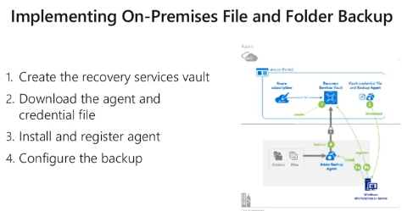

* Requires MARS agent to be installed in the remote machine
  + Mars - Microsoft azure recovery services agent
* Vault > backup > Create
  + Select the workload as on-premise
  + Select what you want to backup
  + Prepare the infrastructure --> installing mars agents
  + Download the recovery vault credentials

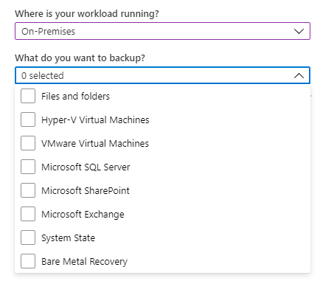

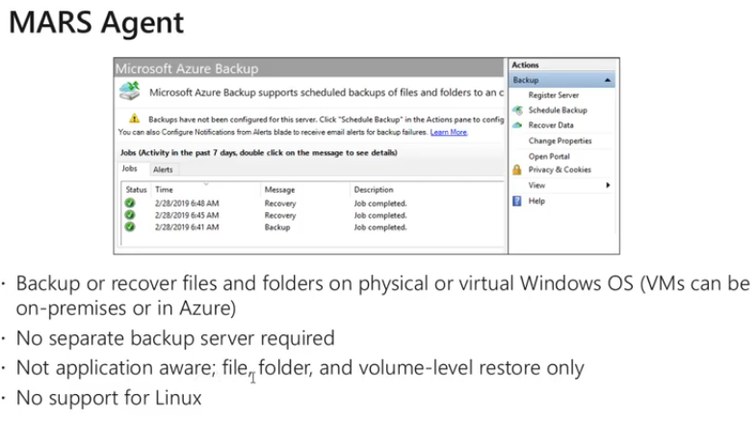

* Removal of a backup vault
* Without deleting the file share backups and de-registering the on-premises backups and any other backups you cannot delete the recovery vault.
* You must delete all the items before deleting the backup.

## Virtual machine backup

* 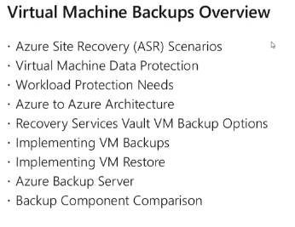

* 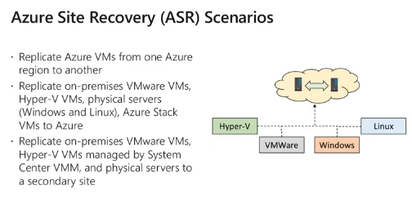

* 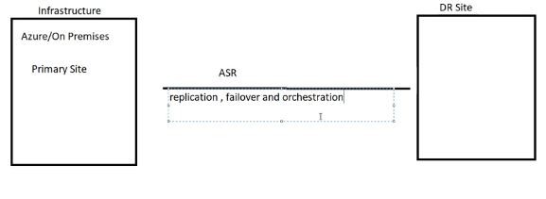
  + Having another site for backup
    - Replication, failover and orchestration happens by ASR

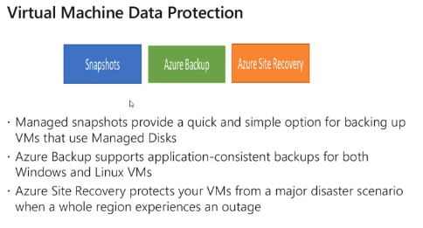

* Virtual machine data protection
* Option 1:
  + Capture - creates an image of the whole vm. Takes in all disks in consideration.
  + Snapshot - take a backup of a single disk. Creates issues when there are dependencies between the os disk and the data disk
    - (Type in search) Snapshot > Create new
* Option 2: Azure backup
  + Application consistent backups for windows and Linux
  + Not a solution for regional level failure
* **Option 3: Azure site recovery** 
  + - For regional level failures

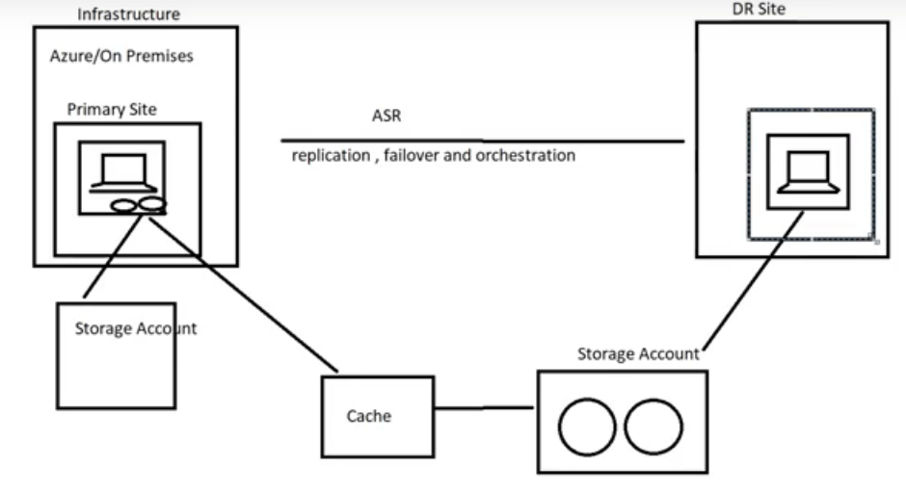

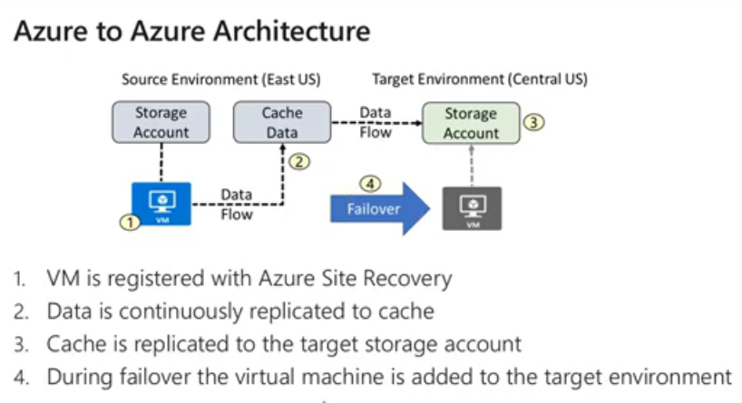

### Things to clarify before starting backups

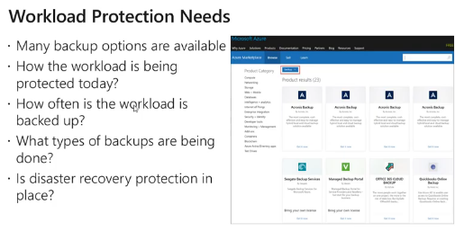

* The new vm created will have the same vnet and the same subnet and everything.

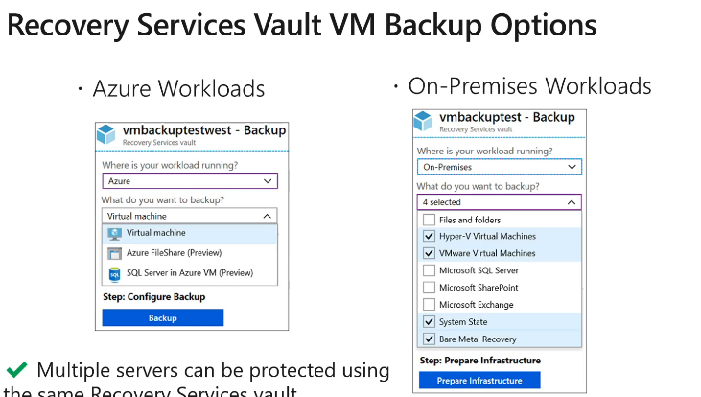

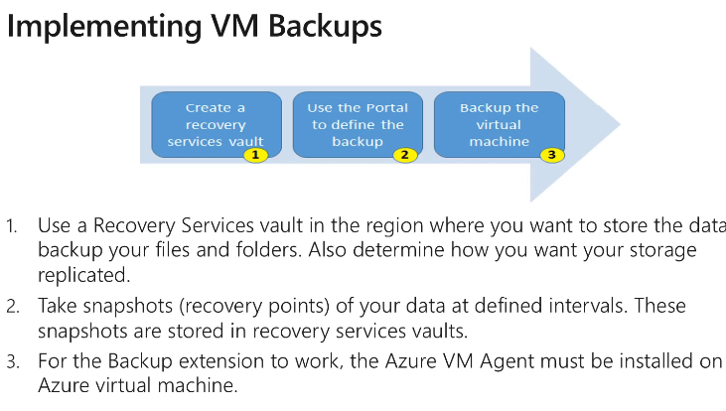

### How to take a VM backup?

* + - My vault > backup > create new
    - Workload = azure, backup= virtual machine
      * Recovery services vault should be in the same region as the backup sources
      * 

* If it is an on-premises VM download and install the MARS agent and register the VM with Azure
* Select backup policy and virtual machine
* 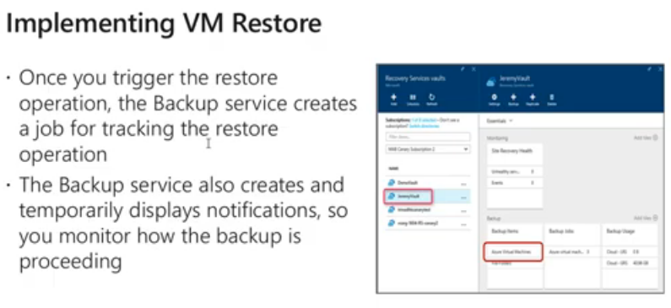

## Azure site recovery - Onsite

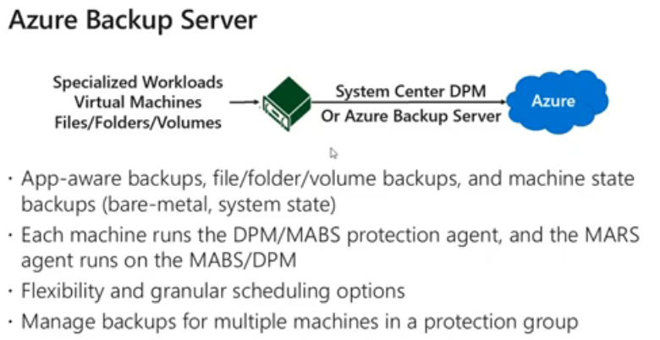

* + The cloud version of that SCDPM is the Azure backup server. SCDPM is the Microsoft on-premise backup server.
  + Takes the backup of the entire environment.

|  |  |
| --- | --- |
| **Azure backup agent**  **Azure backup** | **Azure backup server (Azure site recovery)** |
| Backup files and folders. Not app aware | App aware snapshots. (files folders volumes VMS Applications Workloads) |
| Supports windows only. No support for Linux | Linux and VMware VM's supported |
| No separate backup server required | No support for tape drives, Requires an active azure license. |
| Backup to recover service vault | Backup to recovery service vault or locally attached disk |
| Backup only 3x per day. | No limit |

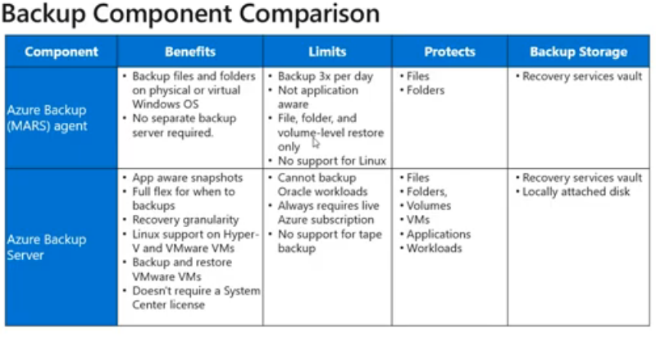

* Create site recovery
  + Create a service recovery vault in a different region than the backup source region. The resource group of the service recovery vault should be in a different region from the backup source
  + Recovery service vault > (getting started) site recovery

# 8. Network Traffic Management

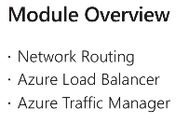

## Network Routing

* 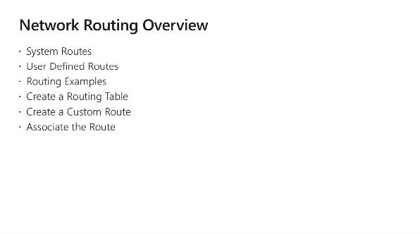
* 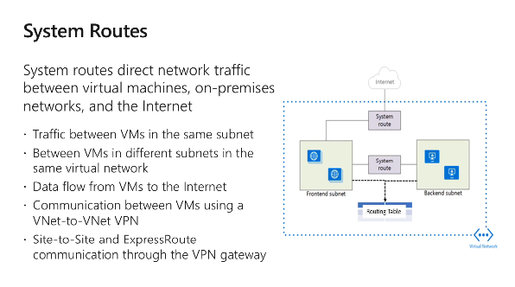

* 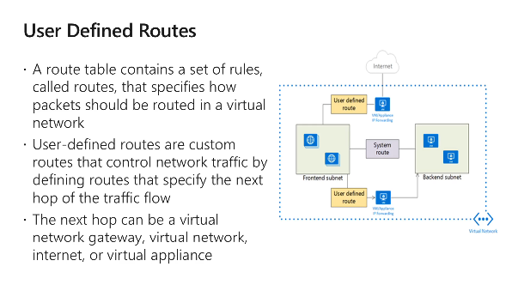

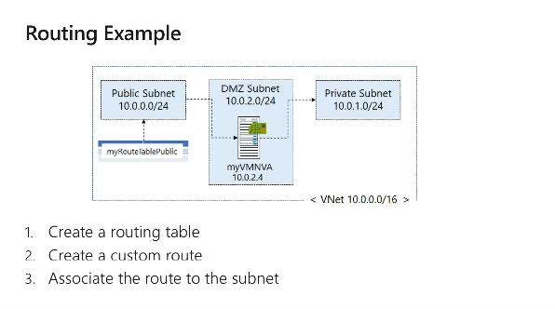

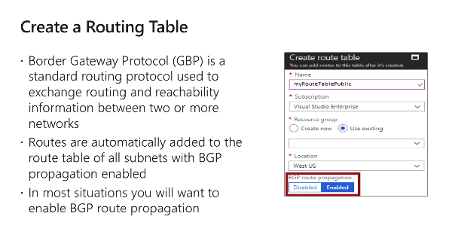

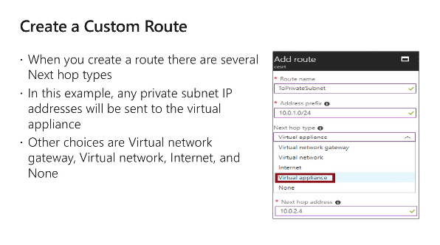

* Default routes (System routes) allows
  + Traffic within subnet
  + Within the same vnet
  + Traffic to a gateway or load balancer
  + Traffic to internet
  + Vnet-vnet virtual machines
  + Site to site and express routes through gateways
* System routes are not displayed in the route table
* In the user defined routes If there is traffic
  + To go to premises - virtual network gateway
  + Internet - internet
  + Firewall - Virtual appliance
  + That should be dropped - none

* 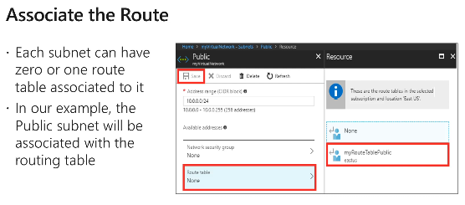
  + Creating and associating routes
    1. Create the route table
    2. Create a traffic route
    3. Assign it to the subnets

## Azure Load Balancer

* 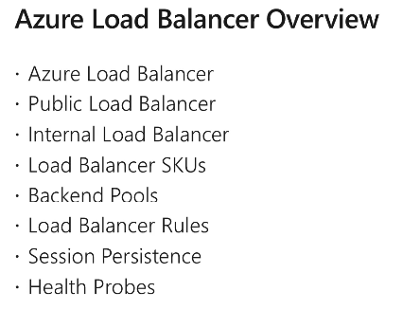

* 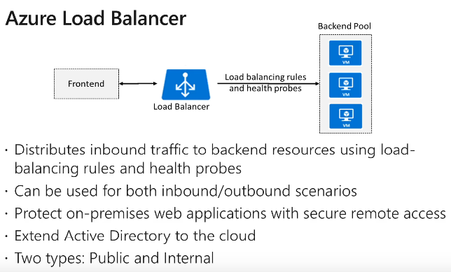
* Load balancer is a level 4 device. Operates in TCP or UDP level
* 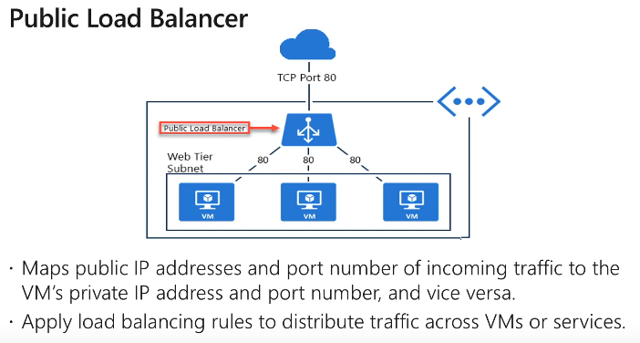

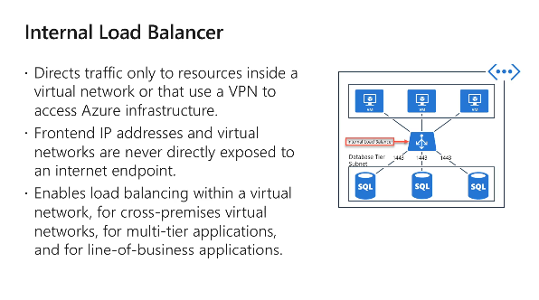

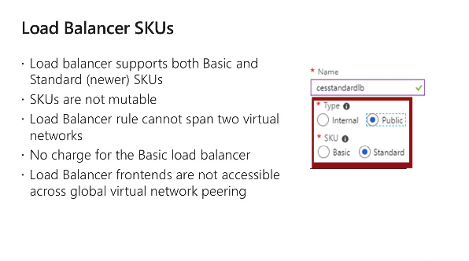

* SKU's cannot be changed later - Mutable
* Both the backend and front-end pools must be in the same vnet
* Now, standard load balancer allows front-end access to globally peered vnets

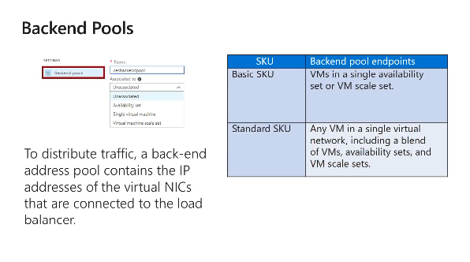

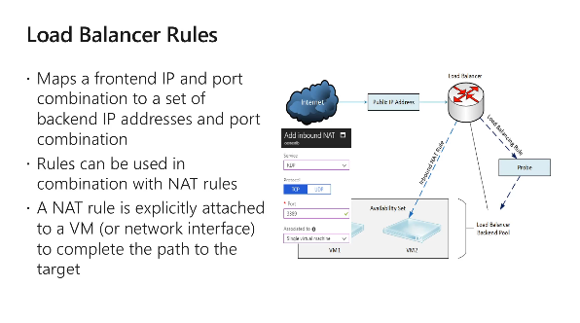

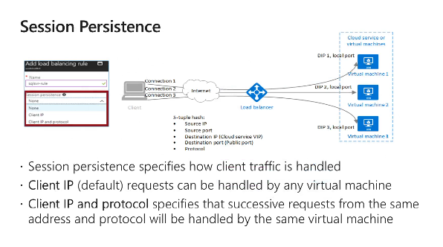

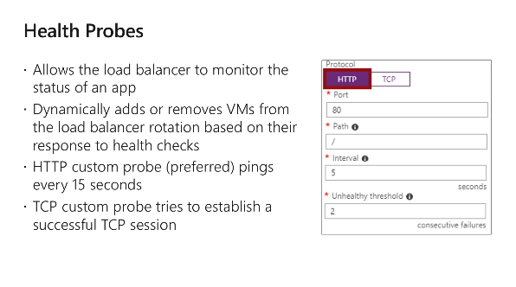

## Azure Traffic Manager

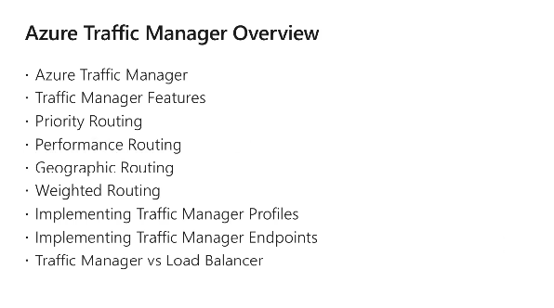

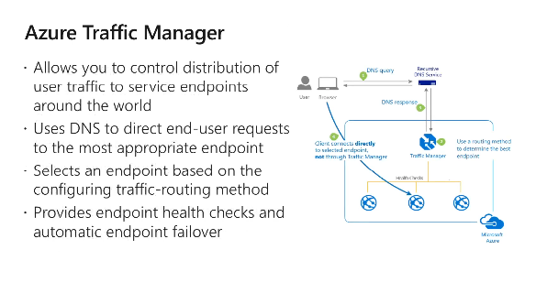

Very helpful in disaster recovery, as it allows routing globally

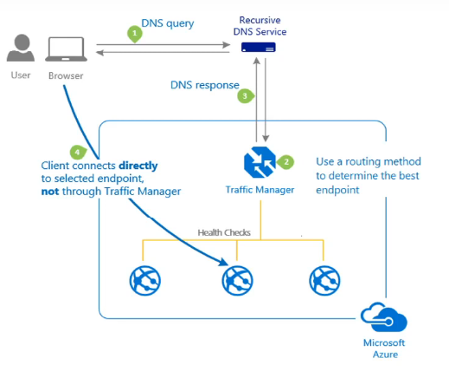

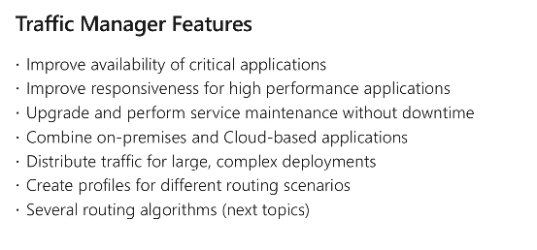

* Can get the user to the closest endpoint
* Traffic routing methods
  + Priority routing
  + Performance routing
  + Geographic routing
  + Weighted Routing
* When a request comes via the DNS server, the traffic manager will return the end-point IP based on the traffic routing method
* Traffic manager will send a TTL value to save that ip at the client.
* Routing weights are decided based on the health of the node monitored via the health probe.
* 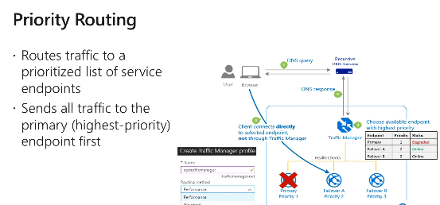

* 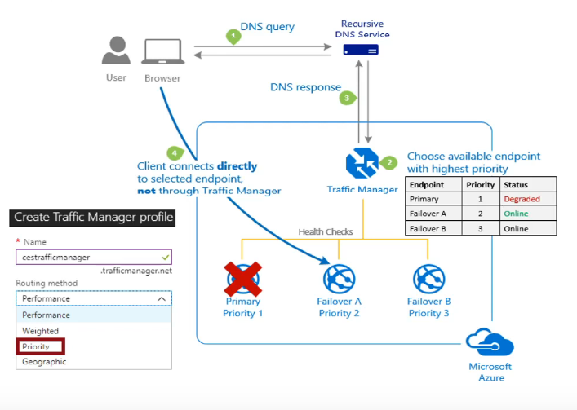

* 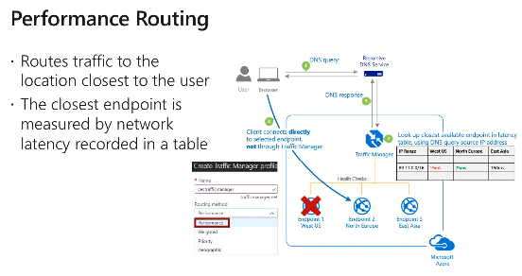

* 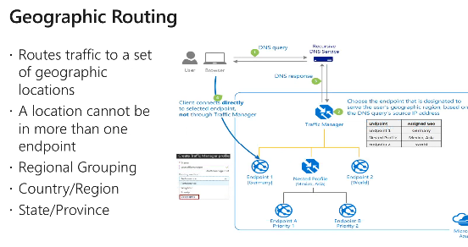

* 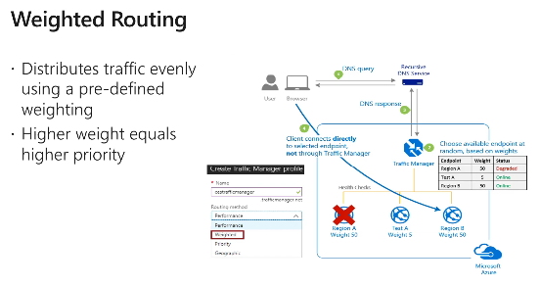

* 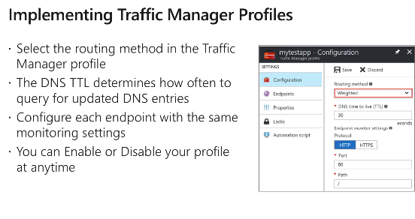

# 9. Active Directory

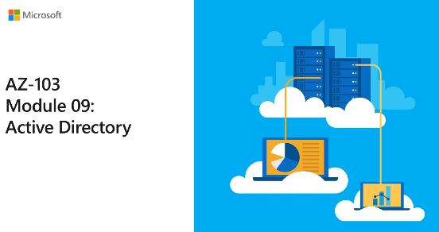

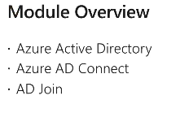

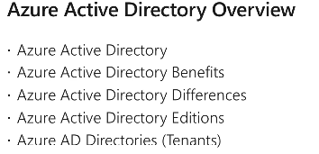

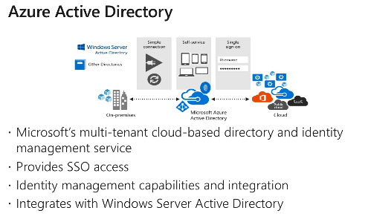

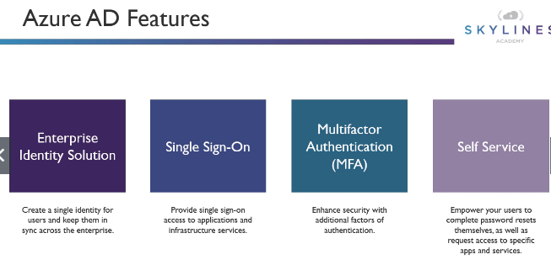

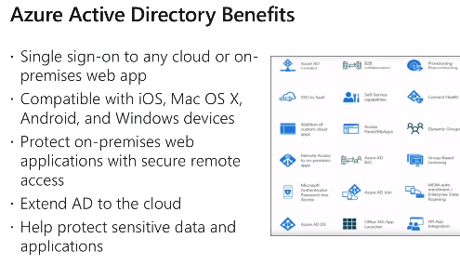

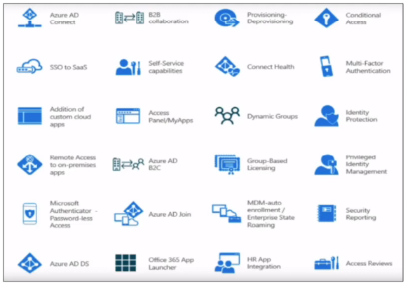

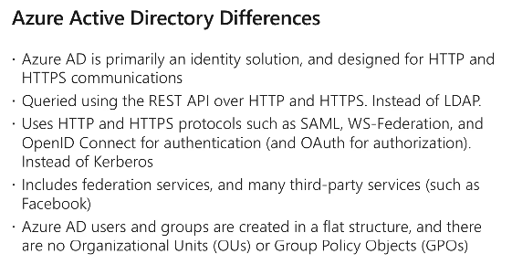

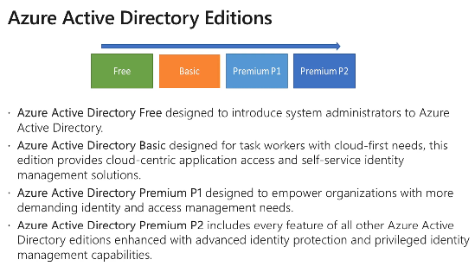

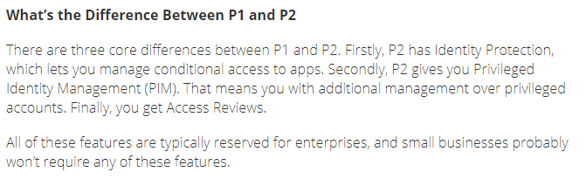

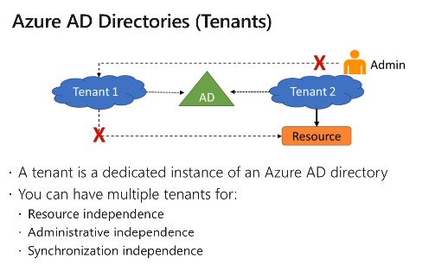

There is a one-to-one mapping for active directory and subscription.

## Active Directory Connect

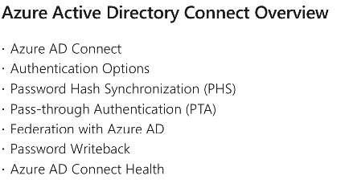

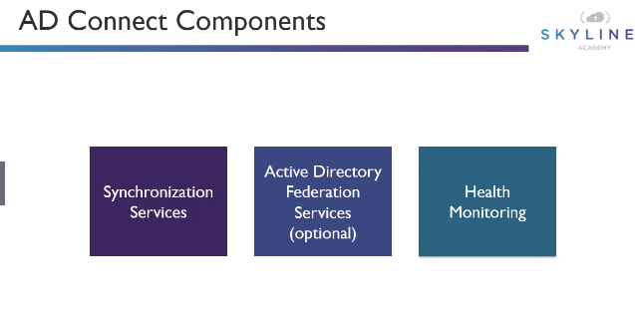

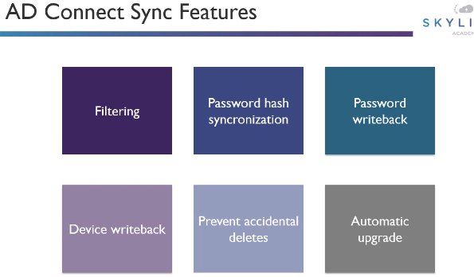

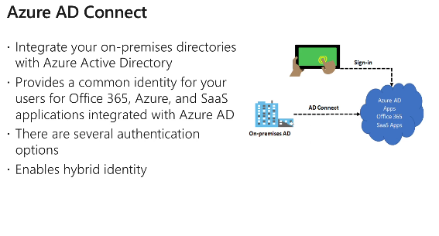

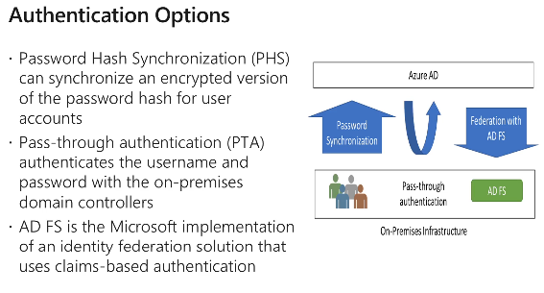

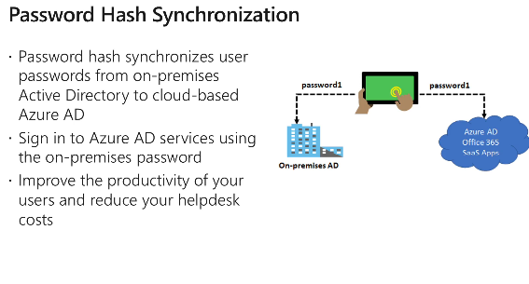

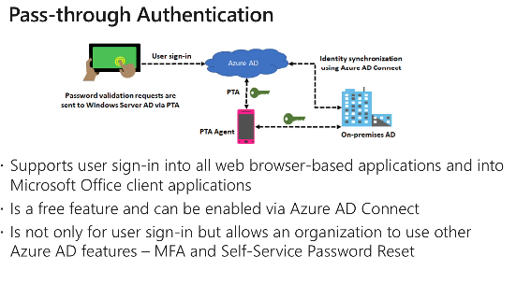

PTA agent needs to be installed in on-premises Active Directory

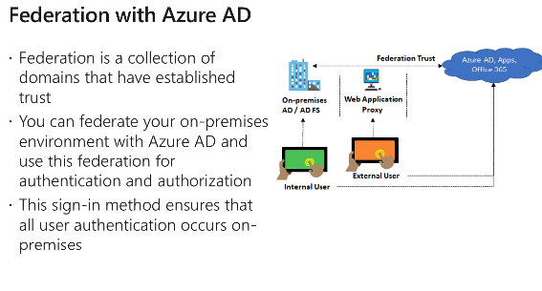

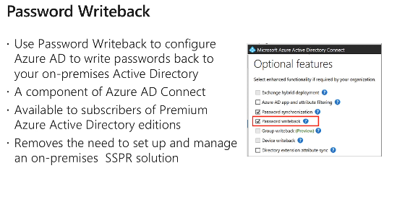

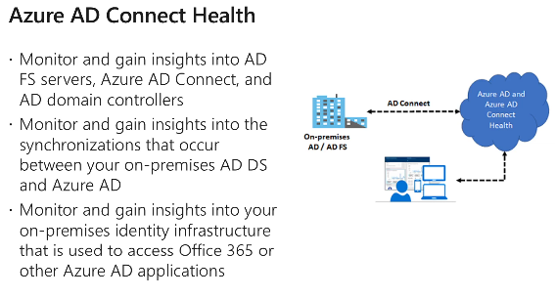

## Azure AD Join

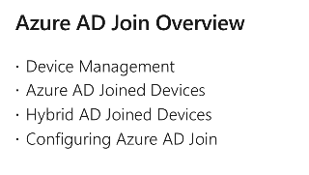

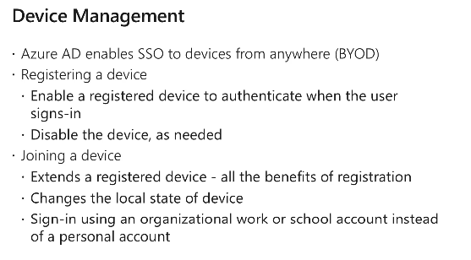

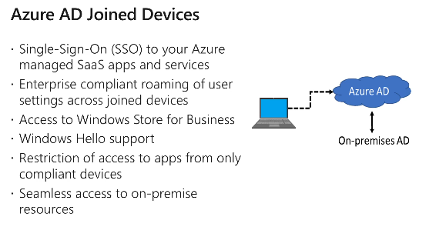

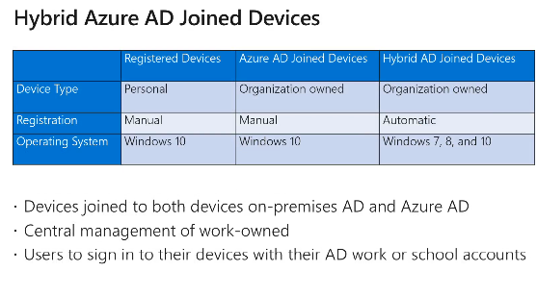

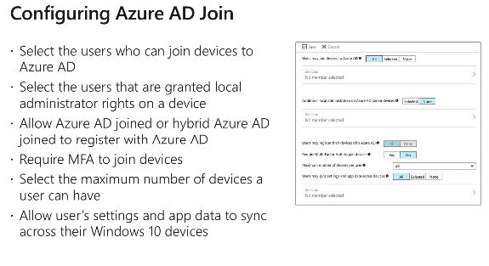

# 10: Securing Identities

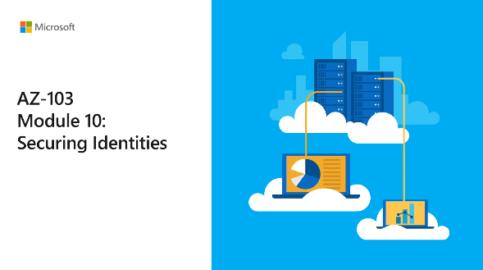

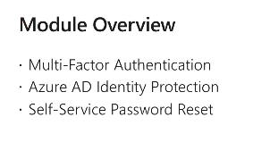

## MFA

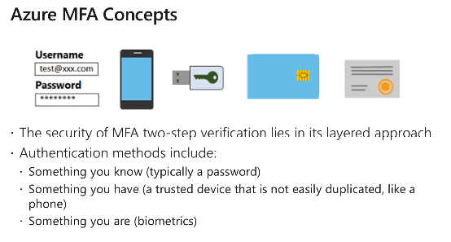

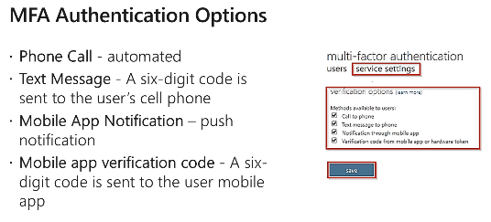

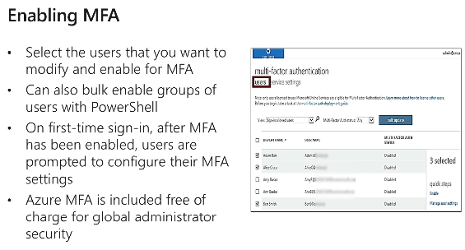

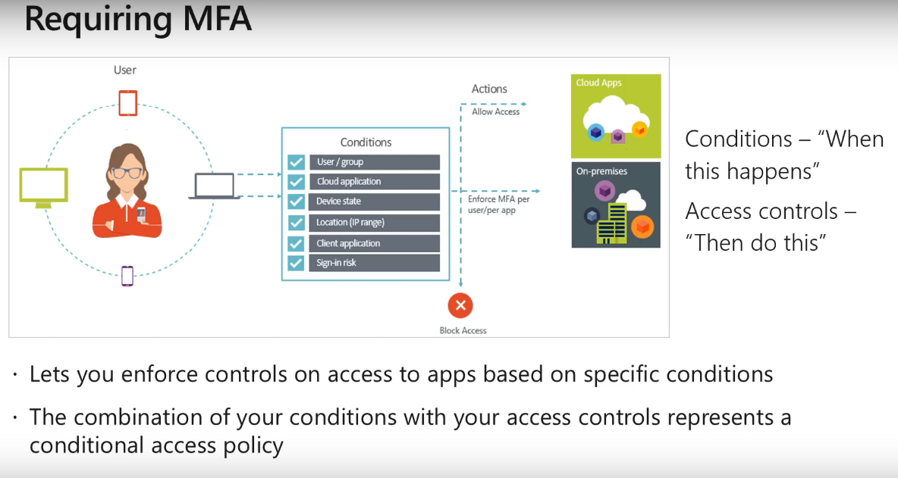

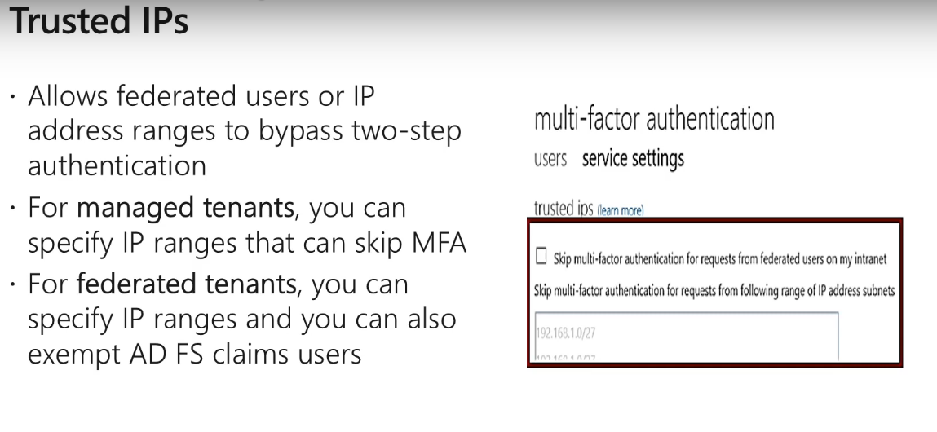

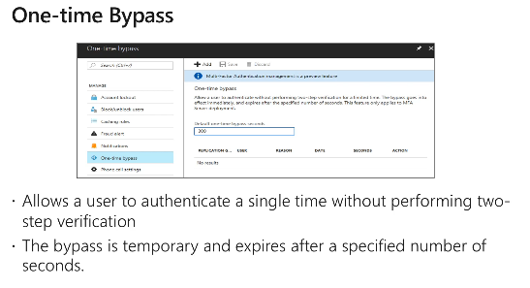

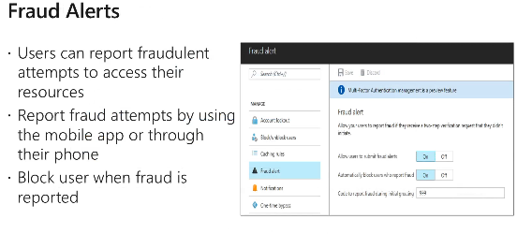

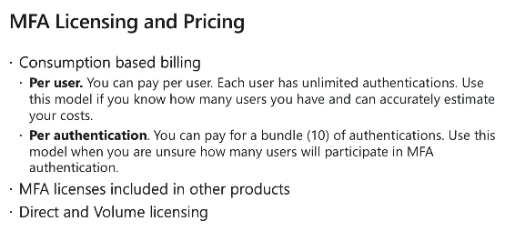

## Identity Protection

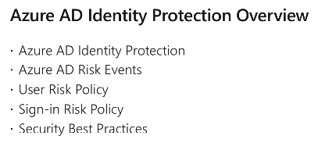



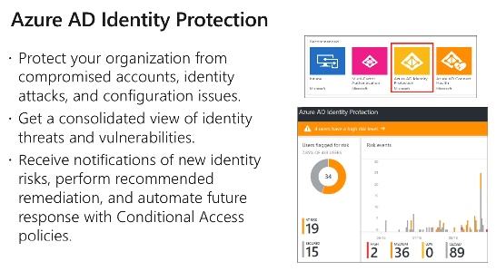

* P2 features in Azure AD

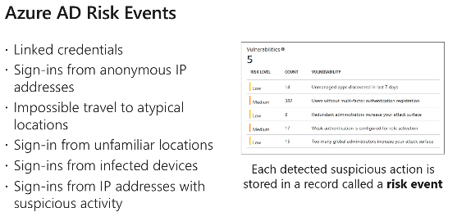

* 2 types of risk policies
  + User risk policy
  + Sign-in risk policy

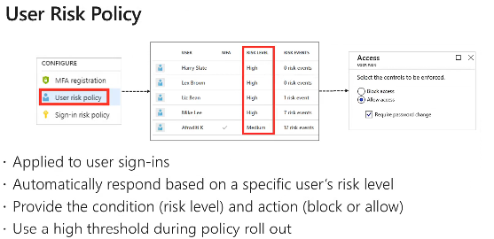

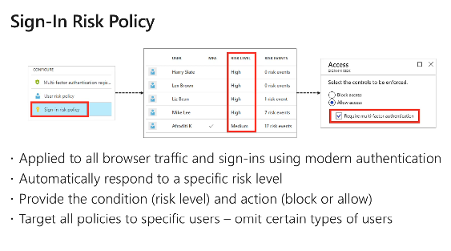

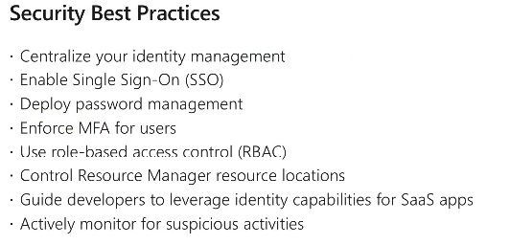

Password policy - Password should have xxx, should be 16 characters etc. etc.

## Self-service password reset

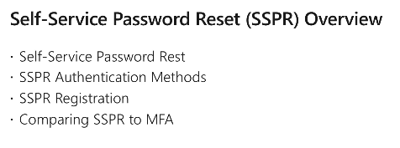

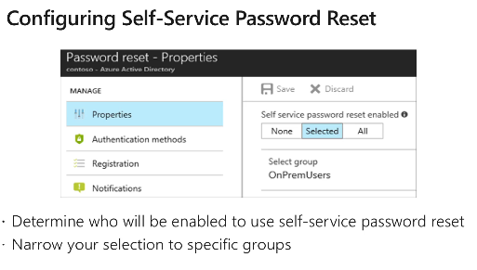

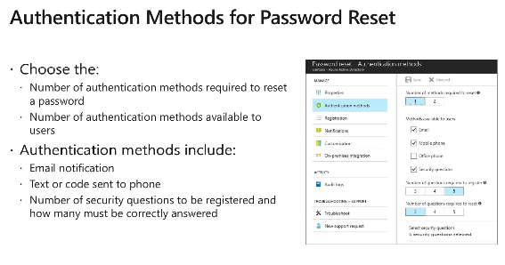

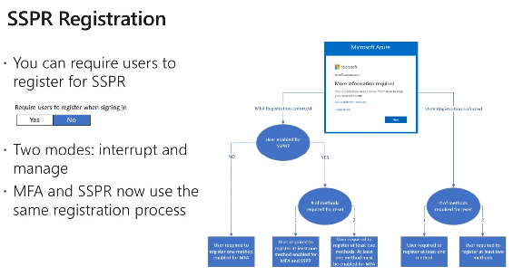

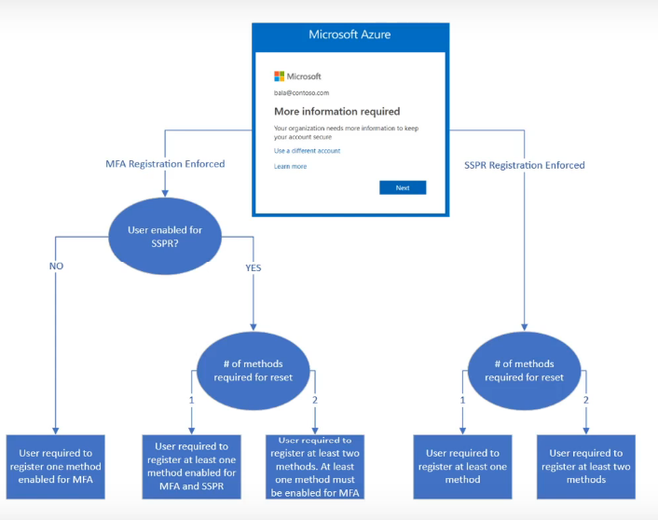

# 11: Governance & Compliance

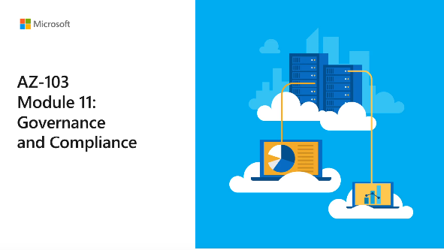

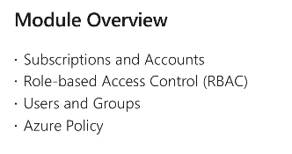

## Subscriptions and accounts

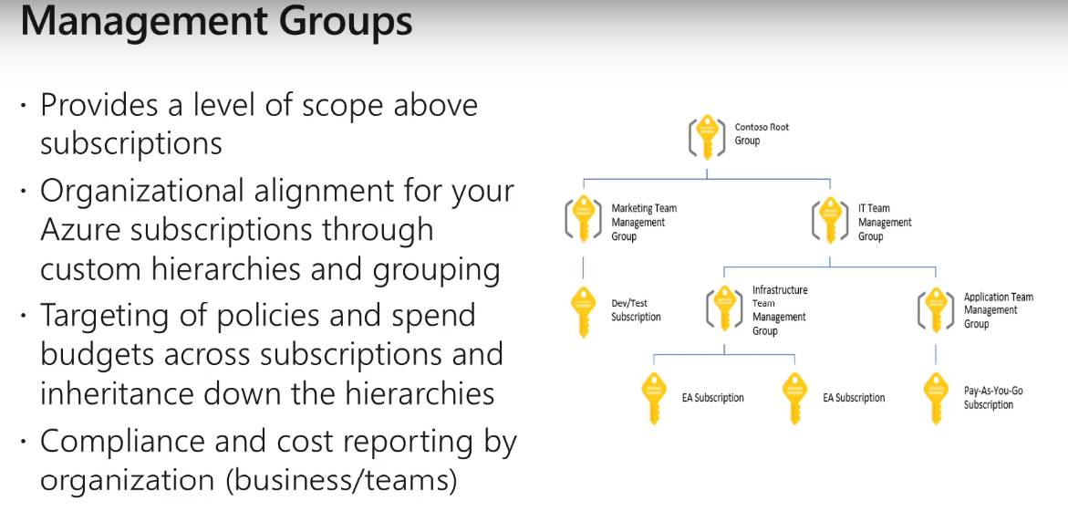

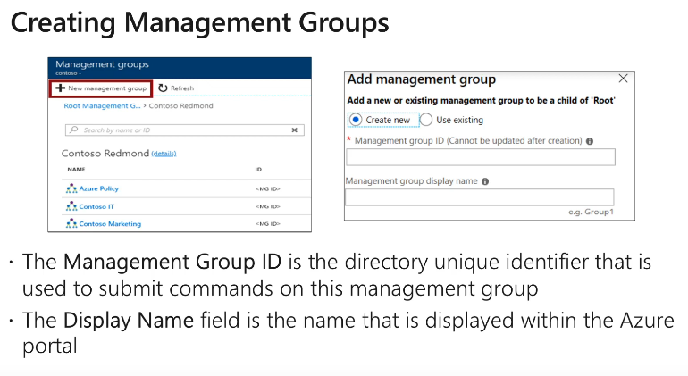

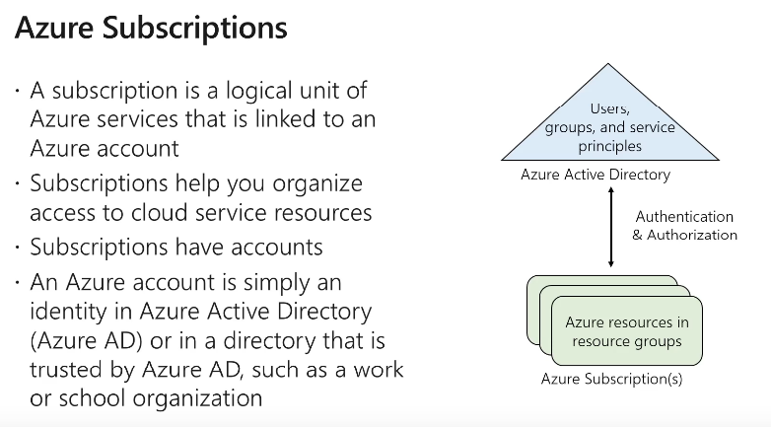

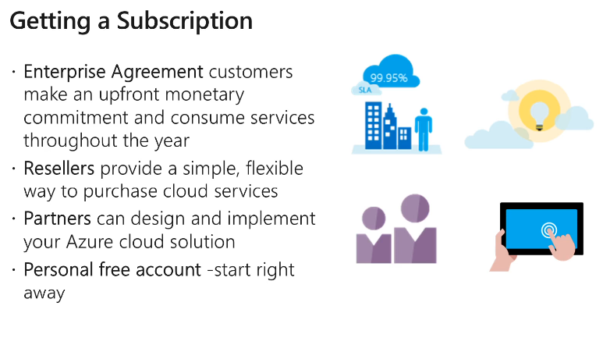

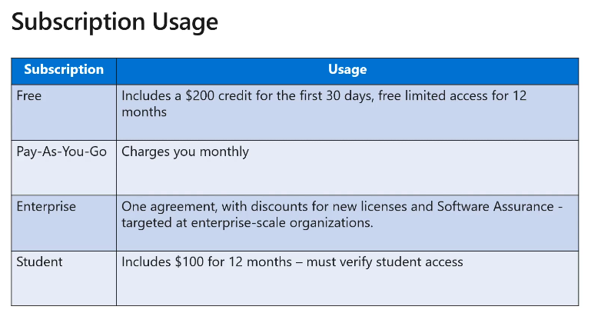

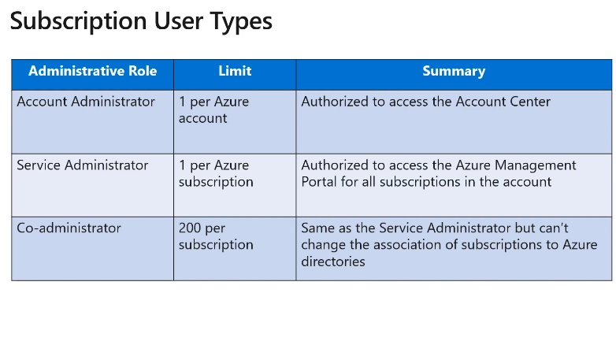

* These are classic roles

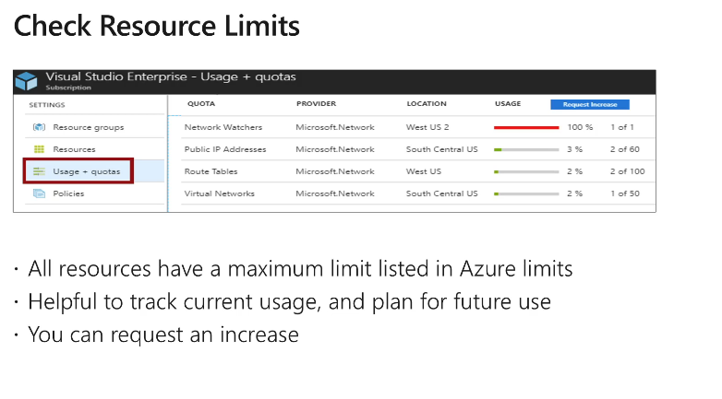

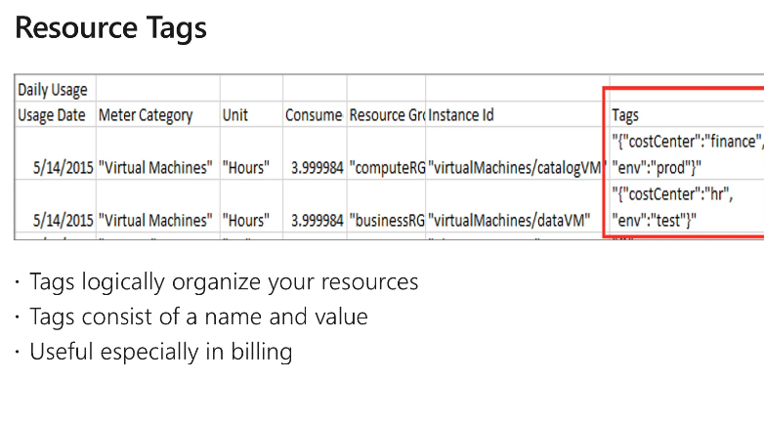

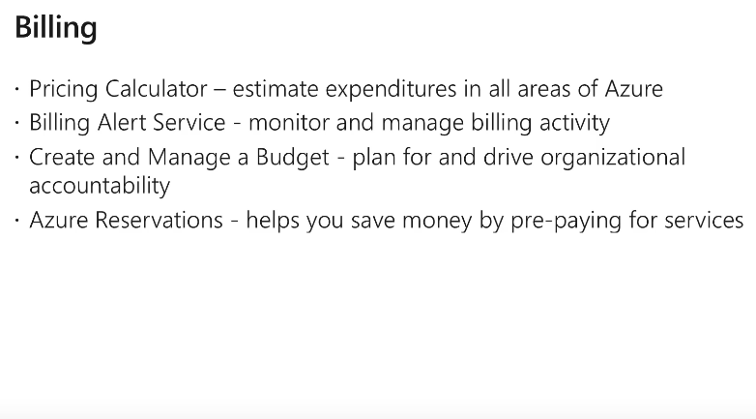

## RBAC

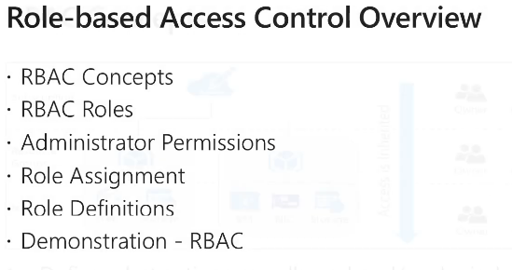

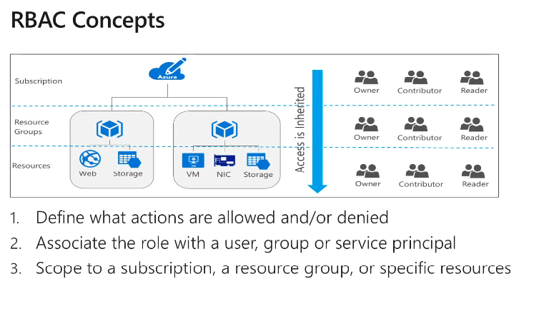

* 3 areas in an RBA
  + **Role** Definition - Owner, Contributor, Reader, User access admin
  + Security principal (The assignee) - User, group, Service principle, Manage identity
  + Scope - Mgt group, subscription, resource group, Resource
* In multirole assignment --> permissions are added.

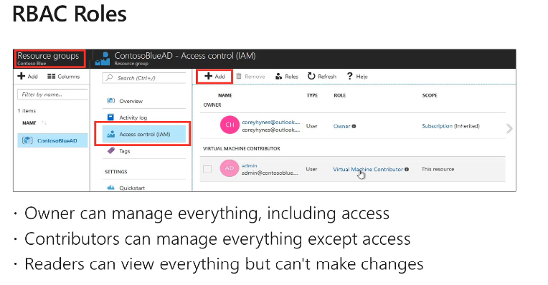

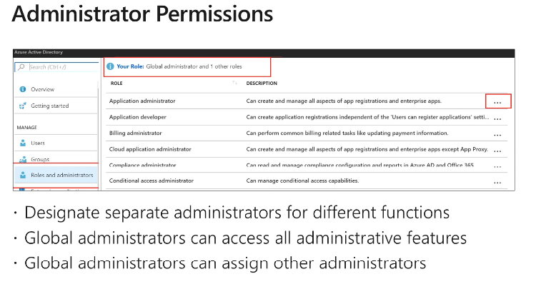

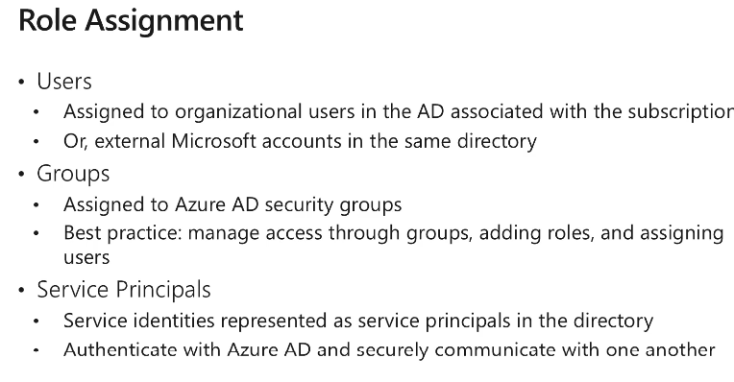

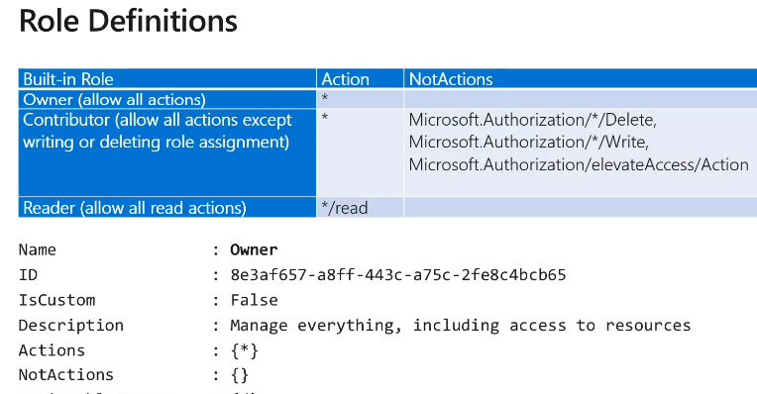

## Users and Groups

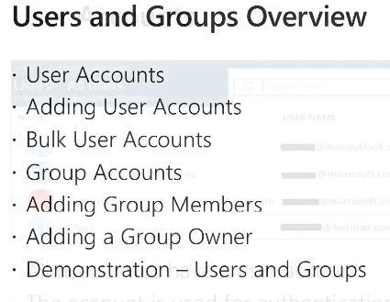

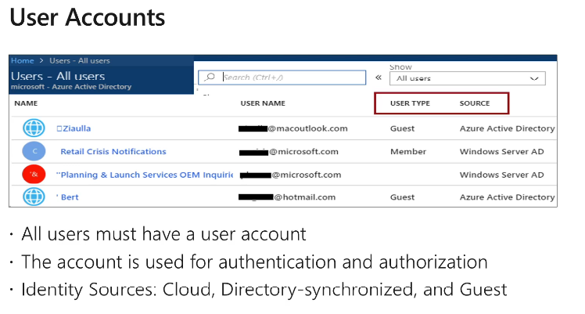

* Identity source
  + Cloud - Users created within azure (User type - Member, Source shown as "Azure active directory")
  + Directory-synchronized - Users created in On-prem AD (“Windows server AD")
  + Guest - Any external. Can be Gmail or Hotmail even. (User Type shown as guest, source AAD)

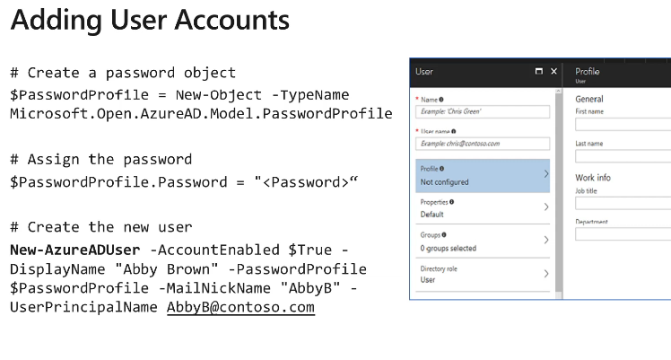

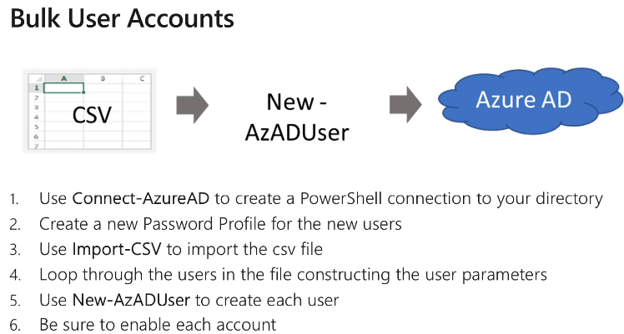

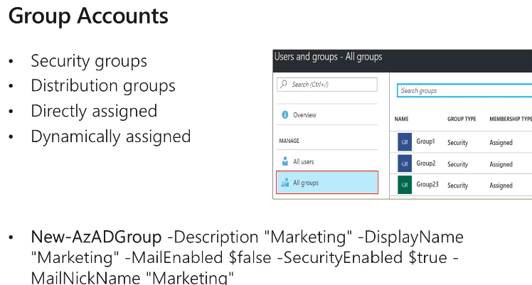

* Two types of groups
  + Security groups - Managing access. RBAC works on this
  + Distribution groups - For email circulation
* 2 ways of assignments
  + Directly - Go to the group and assign the users
  + Dynamically - Assigned based on a rule. E.g. If the users are from accounting, add him to financial services security group

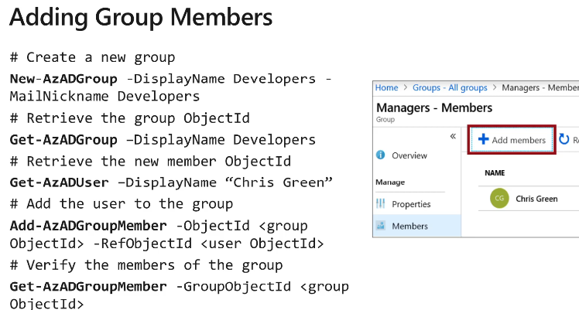

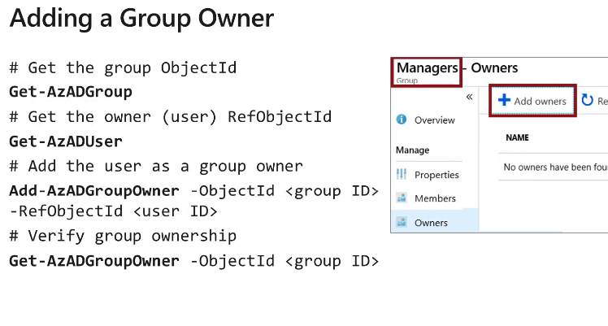

Creating users

* Go to azure active directory blade > Create new user

Creating Groups

* Create new
* Group type - Security or Office 365 (distribution type)

# 12: Data Services

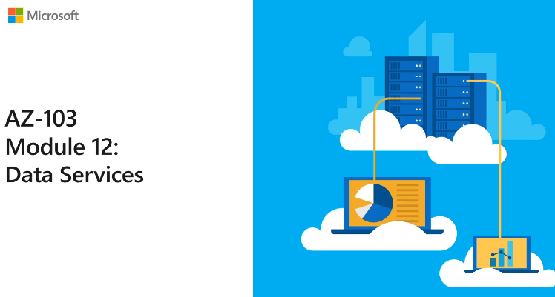

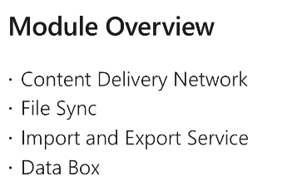

## CDN

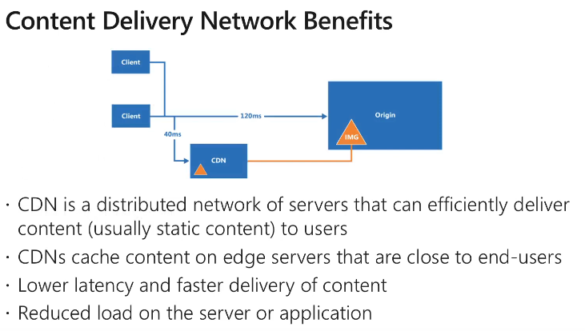

* Origin server - Actual content holder
* Edge server, POP (Point of Presence) - Server that is caching

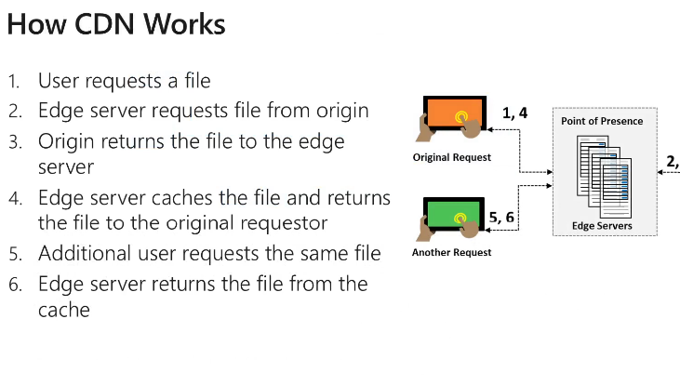

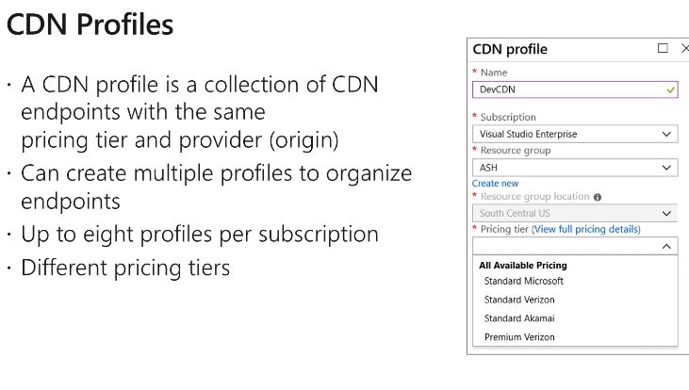

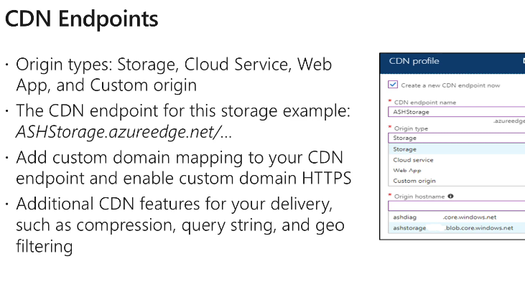

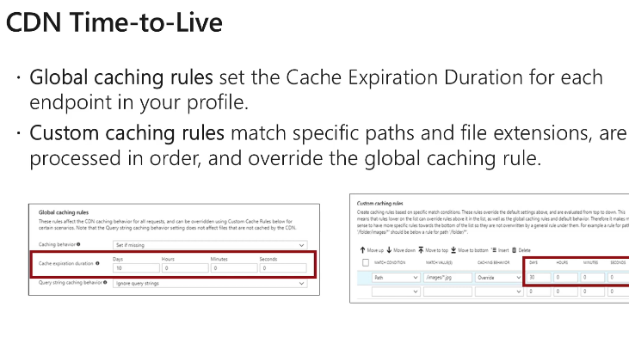

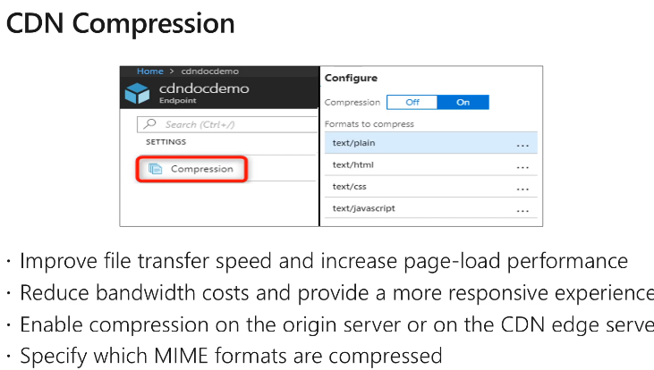

## File Sync

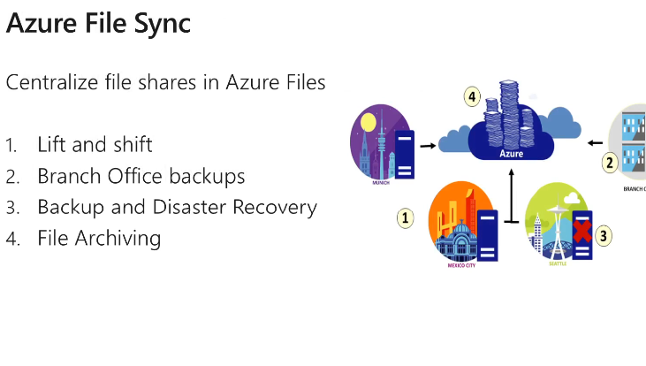

* Advantages
  + Azure file share uses 445 (Samba port). But most organizations block this due to security issues. File sync works on 443 (https). So, no problem
  + Can maintain multiple copies of data. Can be used for
    - Lift and shift. (All 4 above)

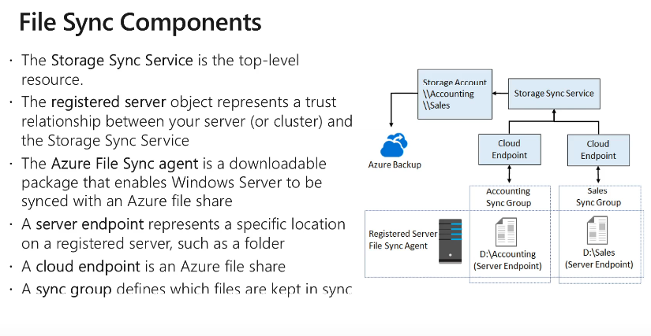

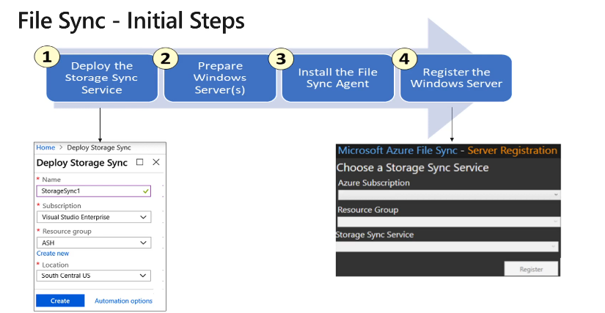

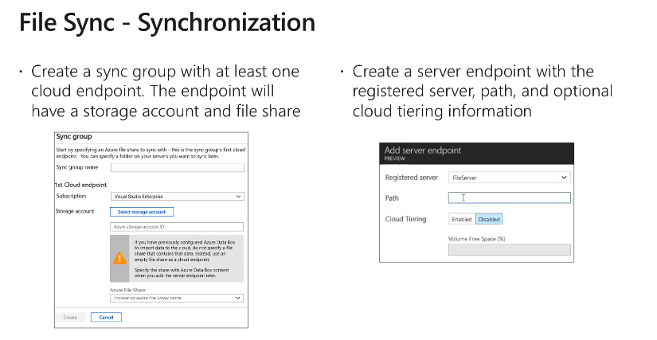

## Azure Import Export

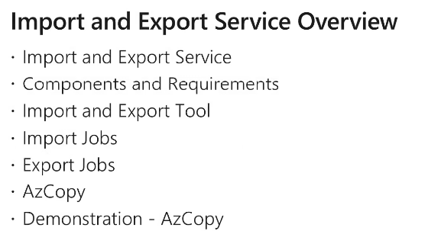

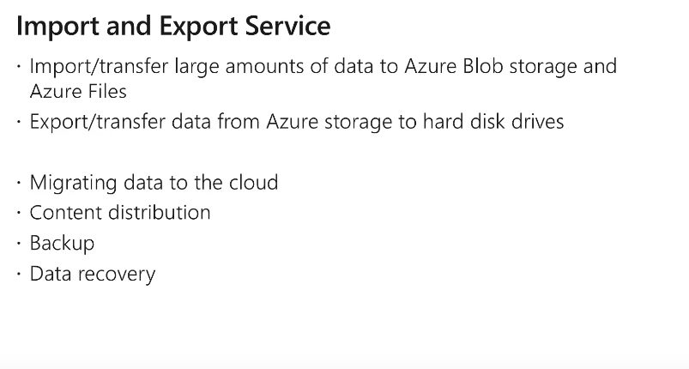

- Scenarios

Migrate data to the cloud. Ship data to the nearest data center

CDN requirement and the data is too large.

Backup and DR data

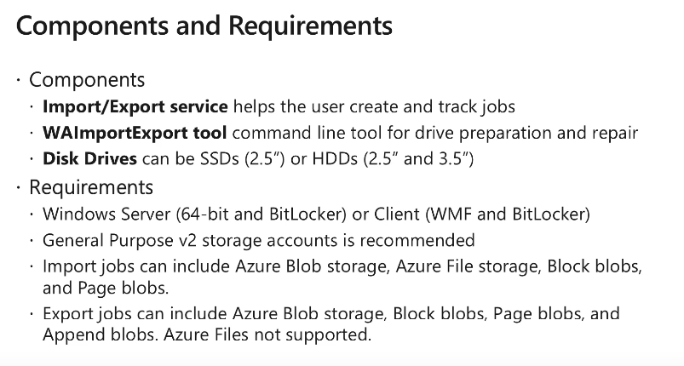

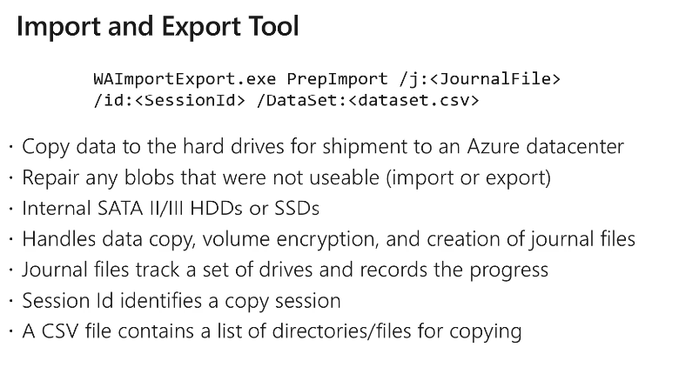

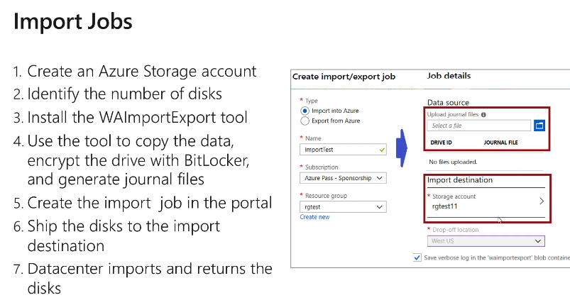

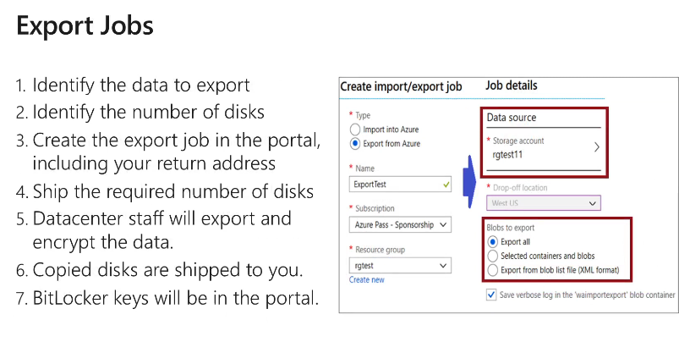

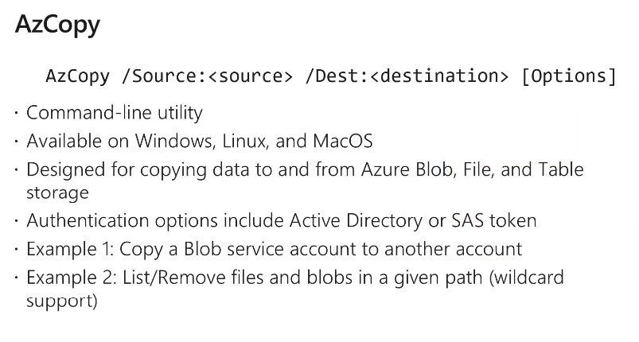

## Data Box

